Faculty profile
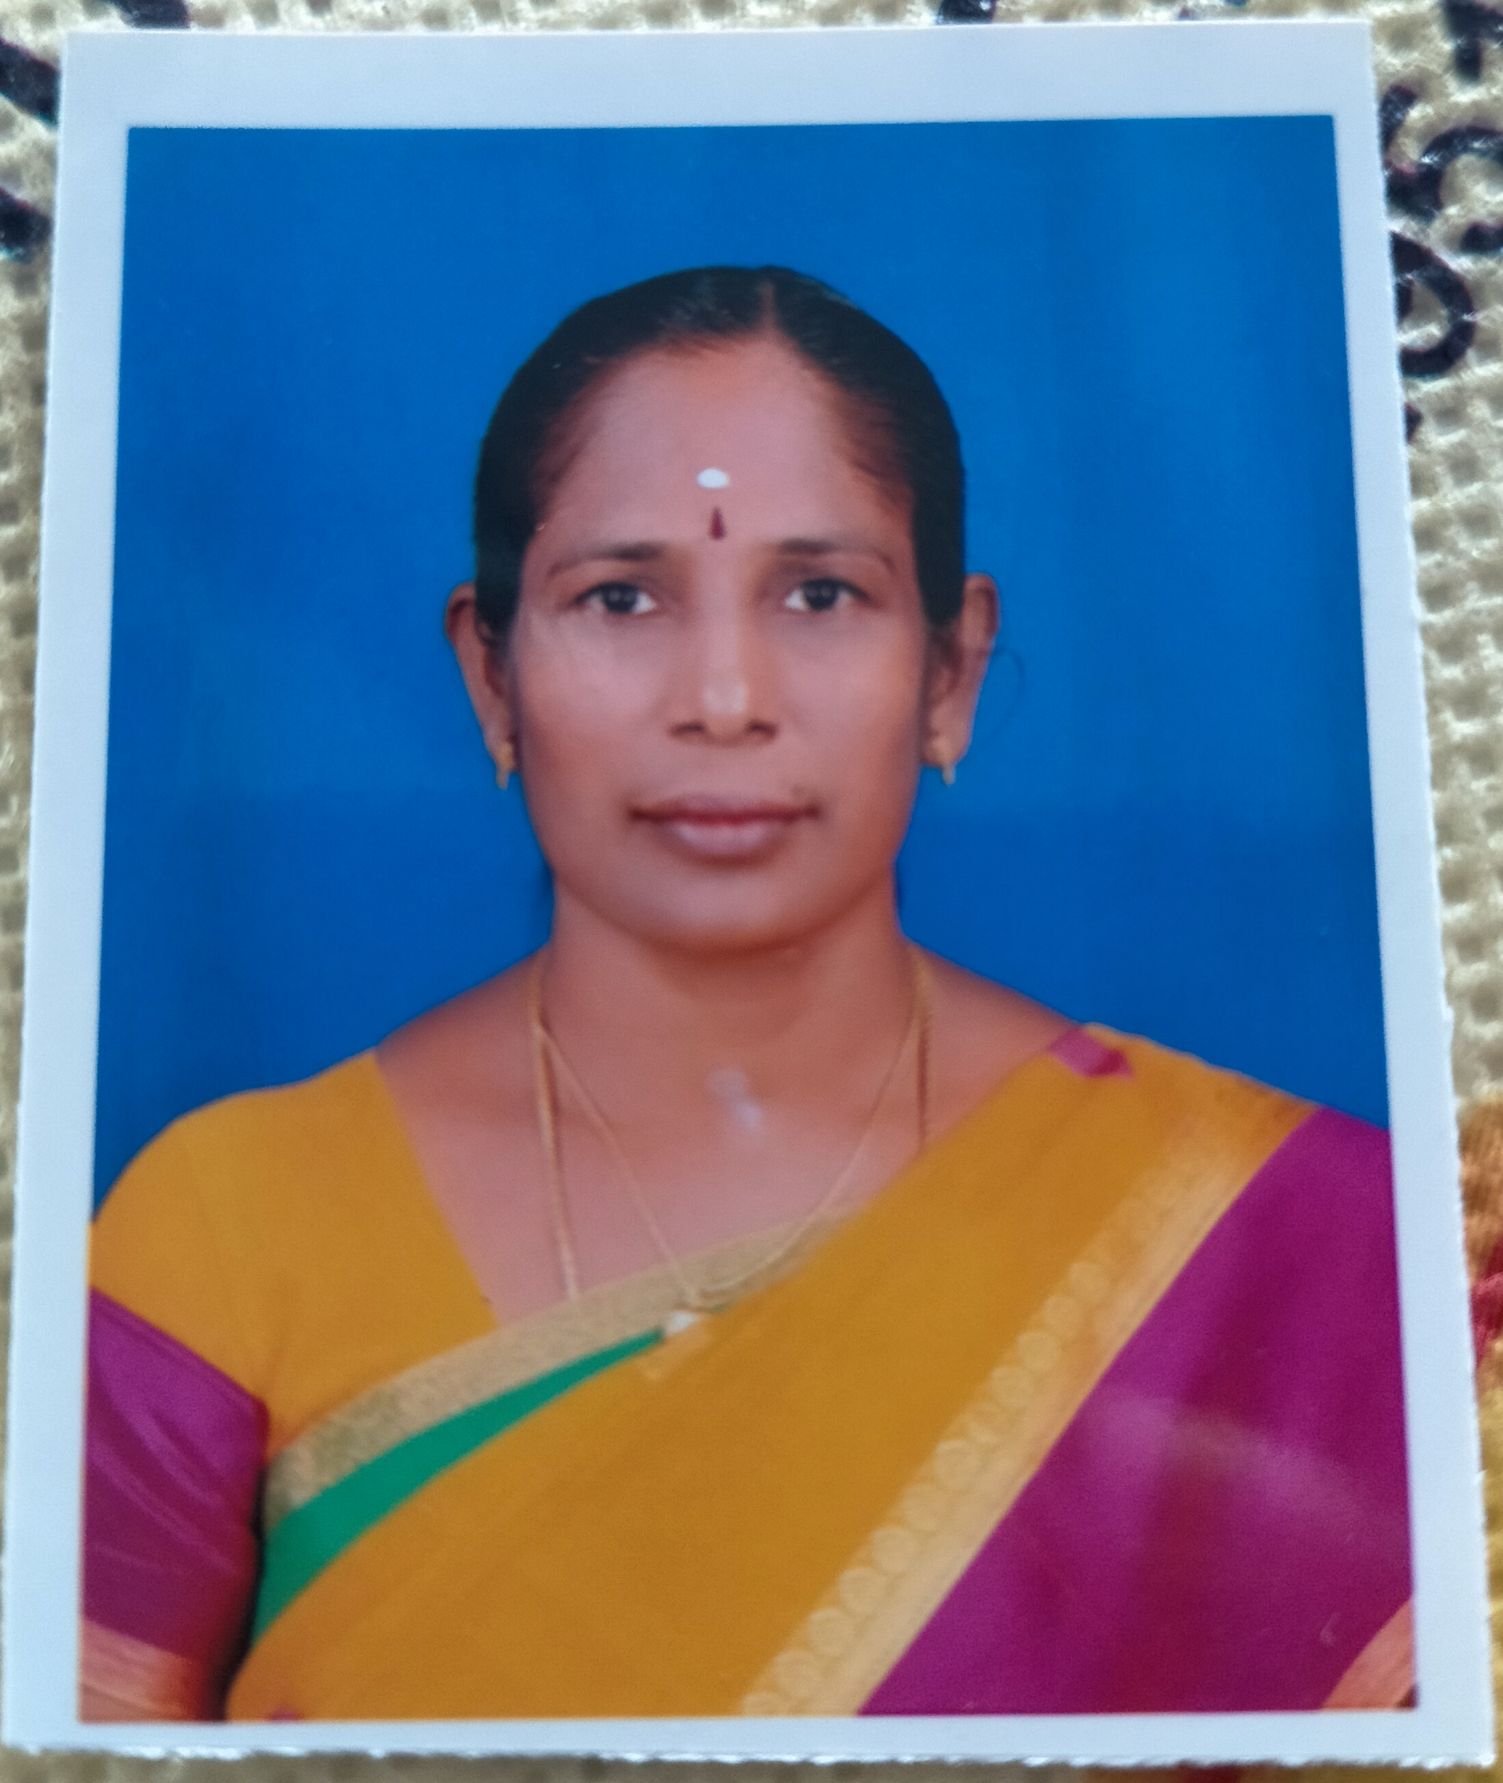
PASSPORT SIZE PHOTO

Faculty Name : Dr.G.MUTHULAKSHMI
Designation : ASSOCIATE PROFESSOR
PEN : 619617
Department : Dept of Tamil & Research Centre
Is HOD : Yes
Permanent Address : Aravind Illam ,Sakthi Garden ,Nallur
Z.Muthur ( Po ) ,Pollachi ,642005
Contact Number : 9497628109 ,9442378109
Email : muthusenthil2010@gmail.com
Experience Details : 16 yrs
Educational qualifications
Course | University/ Institution | Year of Pass
UG | Calicut university / Govt College Chittur | 1995
PG | Calicut university / Govt College Chittur | 1997
M Phil | Madurai Kamaraj University / APA College, Pazhani | 2001
Ph D | Calicut university / Govt College Chittur | 2010
Postdoc | Nil
Others (Specify)
BEd | Calicut university / GHSS Koduvayur | 1999

Broad Area of Research : Folklore , Sankam Literature
Publications(Newest first)
1. 1. Research Papers in Peer-reviewed or UGC listed Journals
Sl. No. | Title of the paper | Journal details (Name, Year, Vol., Pages) | ISSN/ ISBN No. | Whether Peer reviewed,  Impact factor if any*
1 | Kuruthikkalam Kovil Varalaarum vazhipaadum | International Refereed Journal of Tamil studies Research (IRJTSR) | ISSN 2582-5313 -2021
2 | Sangathamizhrin Unavum Virunthompal Panpaadum | SparklingInternational Journalof multidisciplinary Research studies 4  (2),page 25-30 | ISSN 2581-7574  ,2021 | Online
3 | Pandaith Tamizharin Ananku Vazhipaadum PazhankudiMakkalinVanatheevathai Vazhipaadum | Journal of modern Tamizh Research,Vol.17,part 2,page 470-474 | ISSN 2321-984X-Mar 2021 | UGC Care list
4 | Ulaviyal Nokkil Silappathikaram | Journal of modern TamizhResearch ,part 2,pages452-458 | ISSN 2321-984X-Mar 2021 | UGC Care list
5. | Maanidaviyal Nokkil Pathitruppathu | Shanlax International journal of Tamil research,vol-4 ,page 216-220 , | ISSN 244-3993,Nov 2019 | Peer –Reviewed  Scholarly quarterly journal
6 | Sanka Ilakkiyathil Velanmaith Thozhil Nutpam | Shanlax International Journal of arts ,Science and Humanities,Vol 7 no.5page no 140-143 | ISSN 2321-788X-Mar2020 | Peer –Reviewed  Scholarly quarterly journal
7. | Bharathiar Kavithaikalil Manineyap Panbu | Journal of Classical Thamizh,Vol.4 ,no.2 ,page no 433-436 | ISSN 2321-0737-July 2019 | UGC Care list
8. | Pathitruppathil Mannar Aram | Ayidha Ezhuthu,vol.4 ,page no .63 | ISSN 2278—7550-Jan 2019 | UGC Care list
9. | Sanka Ilakkiyaththil Kaimai Vazhakkaarukal– | Journal of modern TamizhResearch Vol.6,no.1 ,page 1-7 | ISSN 2321-984X,2018 jan-march | UGC Care list
10. | Kurinji Nilamum Kuravar Panpaadum – | Journal of Modern Tamizh Research ,Vol.3No.3 ,page no 246-251 | ISSN 2321-984X, july-Sep 2017 | UGC Care list
11 | Kumaaranashan KavithaikaLil Sanka Ilakkiyak Kurukal – | Journal of modern TamizhResearch ,Vol .5 no.2,Page no 247-251 | ISSN 2321-984X,April –june 2017 | UGC Care list
12 | Uppu Vanikamum Kuravar Vaazhviyalum | Pazhanthamizhar Vazhvum Varalarum,Semmoodhai pathippagam,Page No 303-307 | ISBN  978-93-81006-11-5 ,Mar 2016 | -
13 | Tholkappiyathil Tamizhar Vazhviyal Marabukal, | Tamizhar vazhviyal Marabum Mattramum , Semmoodhai pathippagam,Part –V, Page No 250-253 | ISBN 978-93-81006-06-1,Dec2015 | --
14 | Parathiyum Iyarkaiyum | Parathi Panmukap Paarvai , Semmoodhai pathippagam,Vol -2,Page No 1284-1288 | ISBN  978-93-81006-28-3 ,May 2012 | --
15. | Sidhar Padalkalil Ullurai | Valar Tamizh aayvu,Valar Tamizh Research Studies,Dindikul ,Page No 201-213 | ISBN-978-81-920884-1-9 ,May 2012
16 | Sidhar Padalkalil Ilakkiya Nayam | Tamil Ilakkiya vakaiaikalum Samukach Chozhalum,Tamil research Scholars Association,school of tamil Studies,Vol -2 ,Page No 1022-1026 | ISBN-978-81-90778-2-8 ,April2012
17 | Muduvar Vazhviyalil Sanka Marabukal | ResearchCollections,Vol -4 ,Page No 2943-2947 All India College Teachers association ,MK University | ISBN 978-93-80342-57-3 ,2012
18 | Dr U.Ve.Sa Purap porul Venbamalai pathippu | Ve.Saminatha Iyarin Thamizh Pankal,Page No97-100,Annamalai University ,vol-1 | ISBN 978-81-909790-1-6 ,Mar 2011
19 | Muduvar PazhankudiMakkakalin ThirumaNam | ResearchCollections,Vol -4 ,Page No 1944-1949 All India College Teachers association ,MK University | ISBN 978-93-80342-57-may 2010
20 | Tamil Malayalap Pazhamozhikal | Nattuppuraviyal Sinthanaikal  ,page no 107-111,  A.E.Publications,CBE | ISBN 978-81-907928-4-4 ,Dec 2008
* Impact factor to be determined as per Thomson Reuter’s list

Books/ Chapters Published
Slno | Topic | National/International | ISBN No
1 | Muduvar Vaazhviyal , Book , -Author ,2016 | National |  | 819077399-2
2 | Pazhankudi Makkalin Vaaymzhi Vazhakkaarukal ,2019 , | National |  | 978-93-88468-98-5
3. | Tribes of Tamil Nadu: History Society and culture ,2018 | National |  | 978-93-80800-88-2
4 | Sanka Ilakkiyathil Sevviyal Panbukal,Page no 199-209,NGM Coolege ,Pollachi, Ed ,Geethanjali .T,2017 | National |  | 978-81-933882-5-9
5. | Multifarious Treands in Literature page no13-17 ,Emerald Publisher ,Ed Fathima .S.2016 | National |  | 978-81-7966-414-8
6 | Aspects of prosperous life in Tamil Literature ,Page No 86-89 , Published by Avinashilingam Institute of Home science & higher Education for Women,Ed Dr,G.Kalavathi,S.,Dr.,Nov2016 | International |  | 978-93-85267-12-3

Paper Presentations
Slno | Title of paper | Name of Conference | Date
1. | Keralathil Tamizh Pazhankudkal | Keralathil Tamizh Pazhankudkal ,Don Bosko Arts and Science College ,Chennai | Paper Presentation through online mode 16/06/2021 | One day National Seminar (online)
2 | Kala Aayvil Tharavu Sekariththalin padinilaikaL | Nattuppura Aayvu , Kamathenu ars & Science college ,Sathiyamangalam | Paper Presentation through online mode ,09/04/2021 | National seminar  (online)
3 | Pazhankudi Makkal Vaazhvil Sankamarabukal | Panmuka Nokkil Sanga Ilakkiyam ,Govt Arts and Science College ,Munnar | Paper Presentation through online mode ,20/10/2020 | National seminar  (online)
4 | Muth and life –Muduvar tribe | Tribal Muth and life ,KIRTAS ,Kozhikkode | 28 Sep 2018 | National Workshop
5 | Irular pazhankudi Samuthaaymum Thamizhar Panpaadum | Tamil Elements in Kerala Folklore ,Govt Victoria College Palakkad | Dec 2 2016 | Three day National Seminar
6. | Oral Literature in MuduvarTribe | Tribal OralLiterature in the Tamil Region ,Puducherry institute of Linguistics and Culture | ,23 Nov 2016 | Two day National Seminar
7 | Kumaaranashan Kavithaikalil Iyatkai | Nature ,Man and society in Literature ,Govt arts and Science College kozhinjamparai | 25,Dec 2016 | Two day National Seminar
8 | Feminism thoughts in Kumaaranashan Poemsl | Theoritical approaches on modern Literature in Tamil & Malayalam ,Govt College Chttur | 2-4 ,Dec 2015 | Three day National Seminar
9 | Sankak Kavithai Mozhipeyarppu | Transcreation literature in Tamil ,Govt Victoria College Palakkad | ,Nov 2015 | Two day National Seminar
10 | Dramatic aspects in Tribal lore | Drama in Tamil –Theories and Performance ,Govt College Chittur | 16 Nov 2015 | Two day National Seminar
11 | Kumaaranashan Padaippukalum Tamizh Sevviyal Ara Noolkalum | Tamil classical ,Ethical Literature and Cultural Aspects in kerala Arts and Culture , Govt College ,Chittur | 12 Mar 2015 | Three day National Seminar
12 | Proverb in Future | Proverbs :Past – present –Future ,Govt Victoria College Palakkad | 27 Nov, 2014 | Two day National Seminar
13 | Kumaranasan Kavithaikalil Thinai Kotpadu | Retention of Sangam Traditions in Malayalam Language and literature ,University of Kerala ,Kariavattam | 3-5 March , 2014 | Three day National Seminar
14 | Short Stories of Women writers –A Critical View | Tamil Short Stories A Critical View , KeralaUniversity College , Thiruvananthapuram | 26, Mar 2013 | Two day National Seminar
15 | Multiple Perspectives in Tamil Literature | Multiple Perspectives in Tamil Literature ,Govt College Munnar | 4-6 ,Mar 2013 | Three day National Seminar
16 | Muduvar Pazhankudi Makkalin Theyva Vazhipaadu | International Society for Tamil Cultural Studies ,Madurai | 22-23 ,May 2010 | Two day Inter National Conference/Seminar
17 | Annavin Kaathal Jothi | Annamalai University ,Chithamparam | 25 ,Feb 2009 | Two day National Seminar
18 | Vairamuthu Kavithaikalil Samuthaayam | Ainthamizh Aayvaalar Mantram, Senthamizh College ,Madurai | 24 Jan2009 | One day Seminar
19 | Sidhar Padalkalil Iraimachi | The Second world Conference on Siddha Philosophy ,Sathiyabama university,Chennai | 27 Dec 2008 | Three day World Conference
20 | Pattinappalai Kattum Tamizhar Maanbu | Tamizh semmozhi,MGR College ,Hosur | 22-23 Mar 2007 | Two day National Seminar

Areas Of Interest :
- Sankam literature
- Folklore and Comparative Literature

Field of Research :
- Folklore -Ethnography
- Sankam literature
- Comparative Literature

Research Projects and Grants
Sl No | Title | Funding Agency | Amount Sanctioned | Year
1 | Kovai Mavattap pazhankudi Makkal Vazhvil Sanka Marabukal | CICT Chennai | 2.5 Lakhs | 2012---2013
2. | A Comparative Study of CreativeLiterature in Tamil and Malayalam with special reference to Bharathiar and Kumaranashan | UGC | 60000 | 2016--2017

Research Guideship Details
Number of students registered for Ph D : Four
Number of students awarded : Nil
Seminars / Workshops Organized
Sl No | Name of the Programme | Venue | Date
1 | Orientation Programme on Restructuring undergraduate Education –One day workshop | Dept of Tamil ,Govt College Chittur | 26/08/2009
2 | Ethical literary Traditions in Tamil –One day Seminar | Dept of Tamil ,Govt College Chittur | 10/02/2012
3 | Kovai Mavattap Pazhangudi Makkal Vazhvil Sanga Marabugal - One day workshop | Dept of Tamil ,Govt College Chittur | 02/07/2015
4 | ,Dr.C.Govindan Endowment lecture , | Dept of Tamil ,Govt College chittur | 23/10/2019

Professional Appointments(Such as Chairman, Director etc)
Sl No | Position | Name of Institution/Body | Date/Year
1
2

Recognition and Awards
Sl No | Name of Award | Agency | Year
1 | Muthumunaivar V.I.Subramaniyan Award for best research Book (2017) for Muduvar Vazhviyal Doctoral Thesis Published 2016 | TamilNadu Kalai Ilakkiyap Perumantram in alliance with NCBH | 2017
2 | Higher Education leadership Award for Distinguished leader 2019 | Venus International foundation ,Chennai | 2019
3 | Distinguished Woman in Humanities and Social sciences 2020 | Venus International foundation ,Chennai | 2020
4 | Ilam Arinjar 2020 | Porunai ilakkiyak Kalam ,Tamizh Nilamand Nangal Arakkattalai ,Chennai | 2020
5 | Kalam Arivu Maamani ,2020 | Kalam UV Foundation ,ThaiUllam,Hosur Reach media and JCI Hosur Sipcot | 2020

Academic &Administrative Responsibilities
- HOD,
- Chairperson Regular & SDE
- Member Board of Studies

Any Other Details to Specify:

