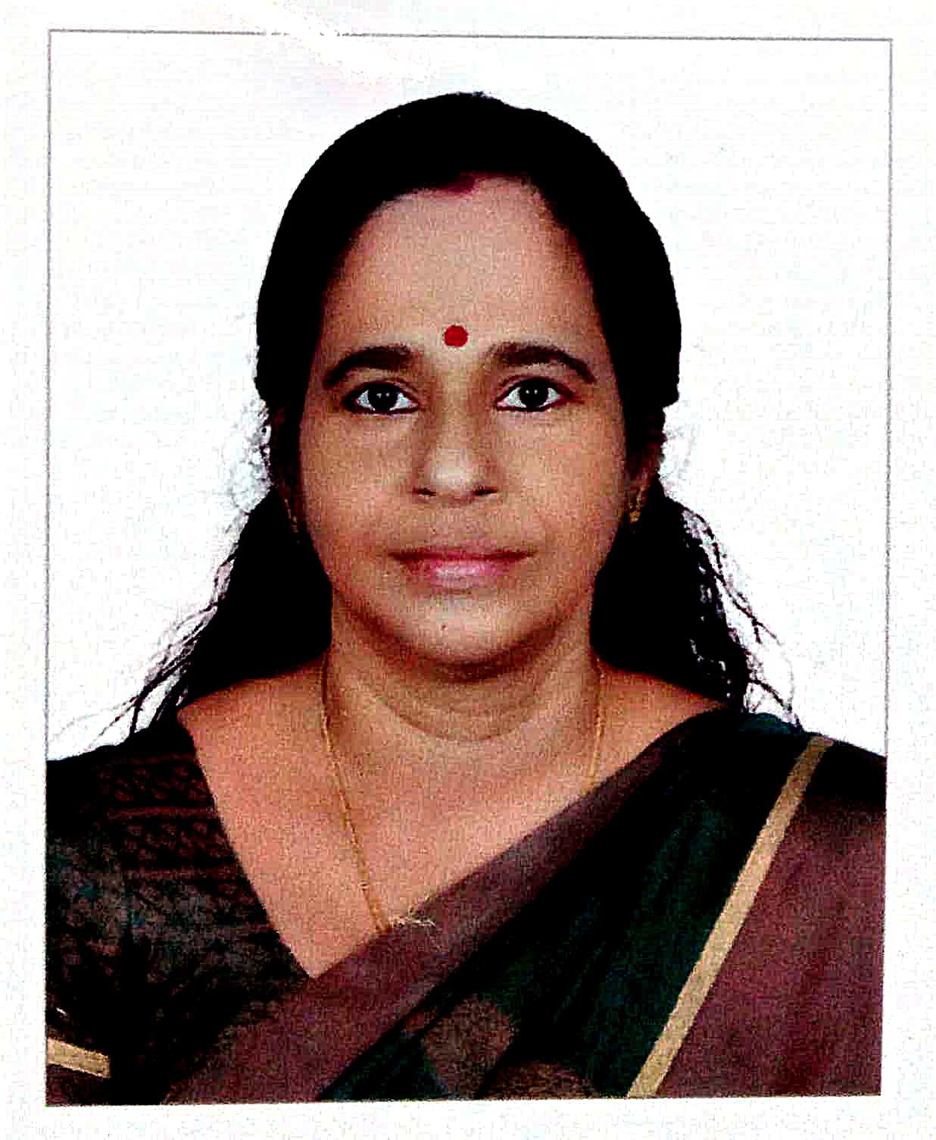
Faculty profile

PASSPORT SIZE PHOTO

Faculty Name :Surekha K R
Designation :UGC LIbrarian
PEN :240594
Department :Library
Is HOD :UGC Librarian
Permanent Address :Kodavamparambil,
Perumpilavu P.O
Ottappilavu, Thrissur, Kerala 680519.
Contact Number :9846351426
Email :surekhalib@gmail.com
Experience Details :
Educational qualifications
Course | University/ Institution | Year of Pass
UG | Calicut (BA), IGNOU (BLISc.) | 1989, 1994
PG | Calicut (MA), Annamalai (MLISc.) | 1991, 2012
UGC NET | UGC | 2013
M Phil
Ph D
Postdoc
Others (Specify) | ETTLIS, SWAYAM | 2019

Broad Area of Research :
Publications (Newest first)
1.
2.
3.

Books/ Chapters Published
1. The Role of Library Professionals in schools under Block Resource Centre, Thrithala, Palakkad District: a study
2. Diet Libraries to Support School Education: A study on Kerala.

Paper Presentations
Sl No | Title of paper | Name of Conference | Date
1 | Role of Library professionals in providing open access resources | National seminar on SKILL APPROACH TO ICT FOR INFORMATION PROBLEM SOLVING | 02-03 January 2015
2 | DIET LIBRARIES TO SUPPORT SCHOOL EDUCATION: A STUDY ON KERALA | National seminar on Technology Management in Libraries | 29-30 August 2014

Areas Of Interest :

i
Field of Research :

Research Projects and Grants
Sl No | Title | Funding Agency | Amount Sanctioned | Year
1
2

Research Guideship Details
Number of students registered for Ph D :
Number of students awarded :
Seminars / Workshops Organized
Sl No | Name of the Programme | Venue | Date
1
2

Professional Appointments (Such as Chairman, Director etc)
Sl No | Position | Name of Institution/Body | Date/Year
1
2

Recognition and Awards
Sl No | Name of Award | Agency | Year
1
2

Academic & Administrative Responsibilities

Any Other Details to Specify:

