Faculty Profile
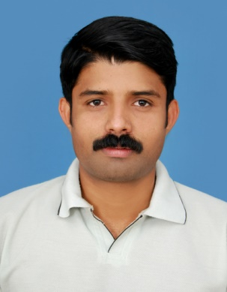
PASSPORT SIZE PHOTO

Faculty Name : Dr. MANU CHAKRAVARTHY.S
Designation : Assistant Professor
PEN : 401480
Department : Physical Education
Is HOD : No
Permanent Address : Chozhan House, Manalthod, K.K. Pathy Post, Chittur, Palakkad
Contact Number : 9809756022, 7559956022
Email : chakrujudo@gmail.com, drmanu@chitturcollege.ac.in
Experience Details : 5 Years of service in Govt.High Schools , 7 Years in College Level
Educational qualifications
Course | University/ Institution | Year of Pass
UG | University of Calicut / Govt.College Chittur | 2002
PG | University of Calicut/ Calicut University Campus | 2004
M Phil | NA
Ph D | University of Calicut | 2021
Postdoc
Others (Specify)

Broad Area of Research :
Publications (Newest first)
- Prevalence of Low Back Pain Among Various Government Subordinate Servants in Palakkad District, ISSN: 2348-2397, 29-03-2021
- Prevalence of Cervical Pain Among Chitti Collection Agents in Palakkad District. ISSN: 2231- 3990, May 2020
- Effect of selected core strengthening workouts & Balanced diet in reducing weight among college teachers under Calicut University, ISSN: 2456-0057, 01-01-2020
- Prevalence of mechanical low back pain among school teachers in Palakkad district, ISSN: 2456-4419, 01-01-2020
Books/ Chapters Published
1.
2.

Paper Presentations
Sl No | Title of paper | Name of Conference | Date
1 | Back Pain: A Universal Language | Ergogenic Aids in Sports. Effects, Risks & Alternatives | March 27th & 28th 2009
2

Areas Of Interest :
- Exercise Physiology & Sports training
- Research Methodology & Statistics

Field of Research :
- Exercise Physiology & Sports training

Research Projects and Grants
Sl No | Title | Funding Agency | Amount Sanctioned | Year
1 | NA
2 | NA

Research Guideship Details
Number of students registered for Ph D : NA
Number of students awarded : NA
Seminars / Workshops Organized
Sl No | Name of the Programme | Venue | Date
1 | NA
2 | NA

Professional Appointments (Such as Chairman, Director etc)
Sl No | Position | Name of Institution/Body | Date/Year
1 | University Team Selection Committee member in Judo, Wrestling, Kho-Kho, Kabaddi, Aquatics | University of Calicut | 2015 onwards
2 | University external examination Committee member in Judo, Kho-Kho & Kabaddi | University of Calicut | 2015 onwards

Recognition and Awards
Sl No | Name of Award | Agency | Year
1 | NA
2 | NA

Academic & Administrative Responsibilities
- Member - College Admission Committee
- Member – College Canteen Committee
- Member – College Staff Club Executive Committee

Any Other Details to Specify:

