Faculty profile
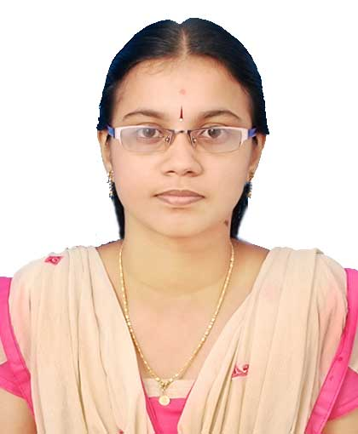
PASSPORT SIZE PHOTO

Faculty Name : Dr. Shilpa M
Designation : Assistant Professor
PEN : 807009
Department : Mathematics
Is HOD : No
Permanent Address : Viswa Vihar, VPN Lane, Thrissur - 680001
Contact Number : 9496838088
Email : rshilpam@gmail.com
Experience Details : 6 years of teaching
Educational qualifications
Course | University/ Institution | Year of Pass
UG | Government College, Chittur | 2008
PG | Government College, Chittur | 2010
M Phil
Ph D | Kerala University | 2019
Postdoc
Others (Specify)

Broad Area of Research :
Publications (Newest first)
1. M. Changat, Prasanth. G. Narasimha-Shenoi, F. Hossein Nezhad, M. Kovše, S. Mohandas, A. Ramachandran, Peter F. Stadler, Transit sets of two-point crossover, Art Discrete Appl. Math. (2020), doi:10.26493/2590-9770.1356.d19. (Accepted)
2. Changat, M., Mohandas, S., Mulder, H. M., Prasanth, G. Narasimha-Shenoi., Powers, R. C., & Wildstrom, D. J. (2018). Axiomatic characterization of the center function. The case of non-universal axioms. Discrete Applied Mathematics, 244, 56-69.
3. Changat, M., Mohandas, S., Prasanth, G. Narasimha-Shenoi., Axiomatic Characterization of Anticenter Function of Some Classes of Graphs., AADM
4. Changat, M., Mohandas, S., Mulder, H. M., Prasanth, G. Narasimha-Shenoi, Powers, R. C., & Wildstrom, D. J. (2017). Axiomatic characterization of the center function. The case of universal axioms. Discrete Applied Mathematics.
5. M. Changat, D. V. Lekha, S. Mohandas, H.M. Mulder, A.R. Subbamthi, Axiomatic characterization of the median and antimedian function on a complete graph minus a matching. Discrete Applied Mathematics.

Books/ Chapters Published
1.
2.

Paper Presentations
Sl No | Title of paper | Name of Conference | Date
1
2

Areas Of Interest :

Field of Research :

Research Projects and Grants
Sl No | Title | Funding Agency | Amount Sanctioned | Year
1
2

Research Guideship Details
Number of students registered for Ph D :
Number of students awarded :
Seminars / Workshops Organized
Sl No | Name of the Programme | Venue | Date
1
2

Professional Appointments (Such as Chairman, Director etc)
Sl No | Position | Name of Institution/Body | Date/Year
1
2

Recognition and Awards
Sl No | Name of Award | Agency | Year
1
2

Academic & Administrative Responsibilities

Any Other Details to Specify:

