Faculty profile
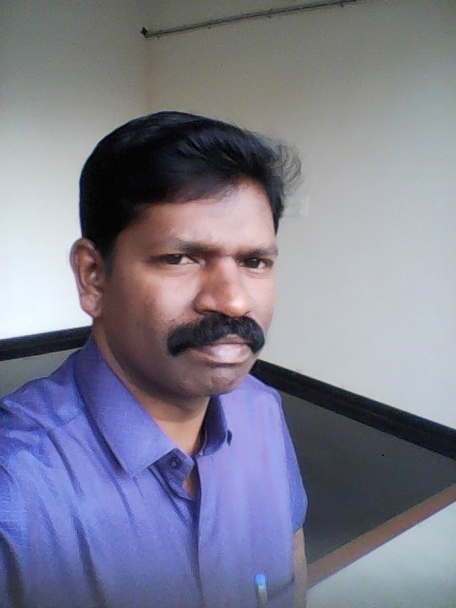
PASSPORT SIZE

Faculty Name : Dr.VIJAYAN.A
Designation :Assistant Professor
PEN :412534
Department :Tamil
Is HOD :no
Permanent Address : Munjamullay Estate L.D Puthuval House, Vandiperiyar P.O Idukki Dt 685533
Contact Number :9497194434
Email :vijayanmullay@gmail.com
Experience Details :20 years, 9 years as Asst.Professor
Educational qualifications
Course | University/ Institution | Year of Pass
UG | Kerala | 1994
PG | Kerala | 1996
M Phil | Kerala | 1999
Ph D | Kerala | 2011
Postdoc
Others (Specify)

Broad Area of Research :Sangam Literature, Grammer, Folklore, Comparitive Literature, Translation, Modern Literature
Publications (Newest first)
1.
2.
3.

Books/ Chapters Published
1. Ellaame PookkaL thaan – Collection of Poem-

2.

Paper Presentations
Sl No | Title of paper | Name of Conference | Date
1 | Vaanithaasanin Kuzhanthai Ilakkiyam | Vaanithaasan Ninaivu vizha | 21/07/2021
2 | Nannool Uriyiyal | National Webinar
3 | MalaiyaaLam | Monther tongue day Congrence
4 | INaiyaththil ThuLippaakkaL | Sahiya Akademi, Chennai, symposium on Webline Literature in Tamil | 12/08/2021
5 | Kerala Idukki Mavatta thamizarkaLin siRu theiva vazipaattu muRaikaL | International Conference on Folklore and  Philosophy, and Other Issues, Malayalam University Malappuram | 17/032019

Areas Of Interest :
- Sangam Literature
- Comparative Literature

Field of Research :
- Sangam Literature
- Comparative Literature
- Grammer,
- Folklore,
- , Translation,
- Modern Literature

Research Projects and Grants : Nil
Sl No | Title | Funding Agency | Amount Sanctioned | Year
1
2

Research Guideship Details
Number of students registered for Ph D :4
Number of students awarded :Nil
Seminars / Workshops Organized
Sl No | Name of the Programme | Venue | Date
1 | Aaiviyal Nookkil Tamil SirukathaikaL | Webinar
2 | Panmuka Nookkil naveena Ilakkiyam | Govt.College, Chittur

Professional Appointments (Such as Chairman, Director etc)
Sl No | Position | Name of Institution/Body | Date/Year
1
2

Recognition and Awards
Sl No | Name of Award | Agency | Year
1 | Eminent Professor Award | Kurinji Tamil Sangam | 2020
2 | Kavi Thentral - | Kanavu, Tiruppur | 2021

Academic & Administrative Responsibilities
- Member, Academic Council, Calicut Univeristy

Any Other Details to Specify:
- Won Prize for my Book – Ellame PookkaL thaan-
- Ex Member, Board of studies, Kerala, Calicut and MG Universities
- Menter SSP
- Coordinator WWS

