Faculty profile
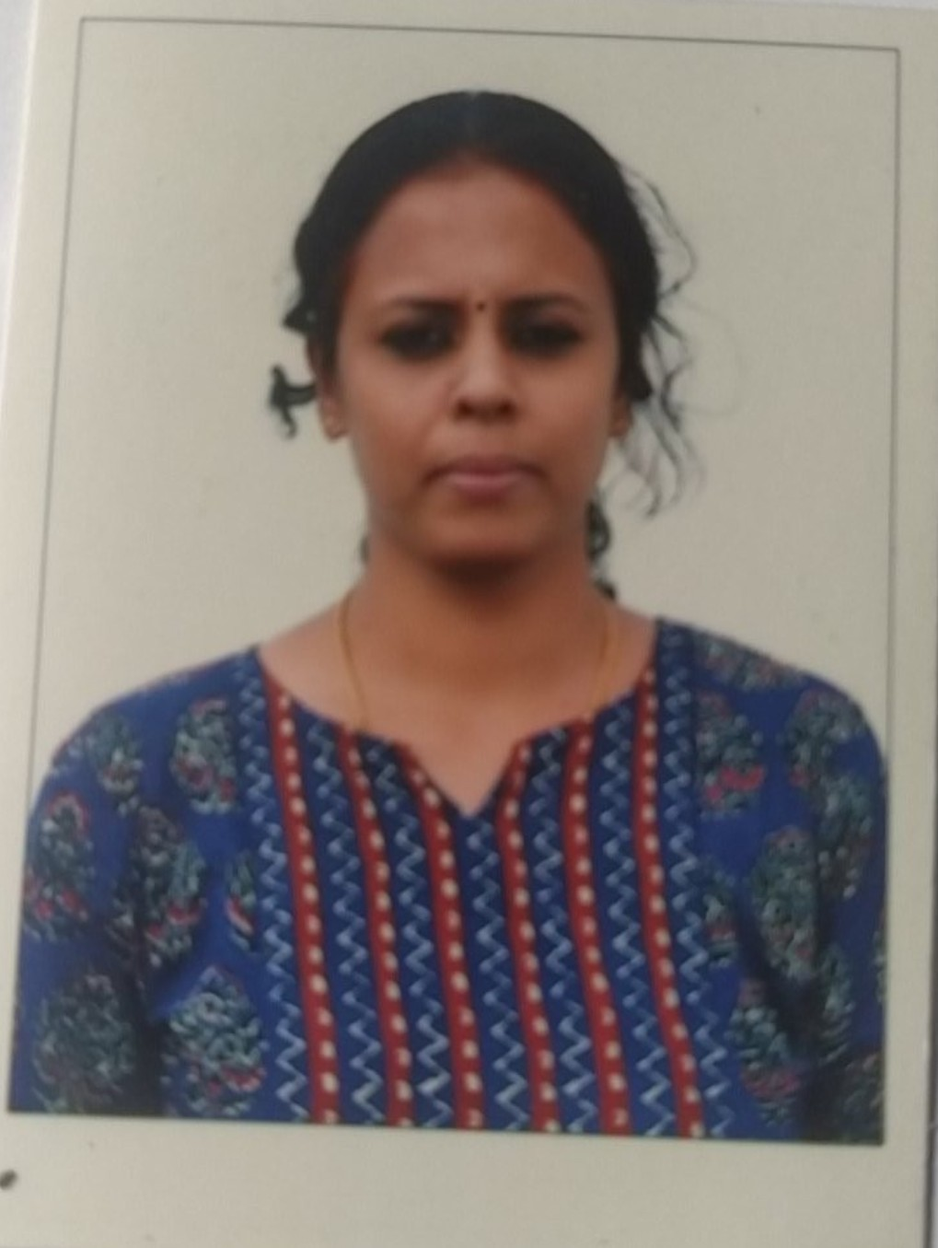
PASSPORT SIZE PHOTO

Faculty Name : Dr. SMITHA P
Designation : ASSISTANT PROFESSOR
PEN : 637736
Department : ECONOMICS
Is HOD : NO
Permanent Address : KUNDU VEEDU, NAIR THARA, KANJIKODE POST, PALAKKAD
Contact Number : 9633863654
Email : smithaanishp@gmail.com
Experience Details : 12 years
Educational qualifications
Course | University/ Institution | Year of Pass
UG | University of Calicut | 2003
PG | University of Calicut | 2005
M Phil
Ph D | BHARATHIAR UNIVERSITY | 2019
Postdoc
Others (Specify) | B.ED | 2007

Broad Area of Research :
Publications (Newest first)
1. “An analysis of the Growth and Status of Banking Sector in Kerala”, Dr. D Elango & Smitha P, International Journal of Informative & Futuristic Research, ISSN:2347-1697, Vol 5, Issue 5, January 2018, Pages 9037-9043

Books/ Chapters Published
1. “Problems and Determinants of Access to Formal Credit to Women Entrepreneur in Palakkad District, Kerala”, Smitha P, Manju Varghese & Sumathy M, Women in 21st Century: A Global Scenario, Amit Bhowmick, Elias Olukorede Wahab, Mittal Publications, New Delhi, ISBN 978-81-947123-5-0
2. “Analysis of the Socio-Demographic Profile of Women Entrepreneurs in Palakkad District: With Special Reference to MSME Women Entrepreneurs” Dr. D Elango & Smitha P, Gender Perspectives From Global Lens, Prabhat Kumar Singh & Amit Bhowmick, Adhyayan Publishers & Distributors, New Delhi(India), 2018, ISBN 978—81938077-4-3.

Paper Presentations
Sl No | Title of paper | Name of Conference | Date
1 | - Presented a paper on “Growth of Banking Network in Kerala and Palakkad: A Comparative Analysis”. | International Seminar on Monetary Policy Debates – The Slowdown Scenario organized by Dept. of Economics, NSS College, Ottapalam | 12th & 13th February 2020
2 | Presented a paper on “Green Banking Initiatives for Sustainable Development” | two day National Seminar on “Implications of Environmental Economics on Restructuring Kerala” organized by PG Dept. of Economics, Govt. College Chittur, Palakkad | 22 ^{nd} & 23rd November 2018.
3 | Presented a paper on “A Comparative Study of the Banking Industry in Kerala In Terms Of Selected Parameters” | at the two day National Seminar on Structural Transformation in the Indian Economy: Trends, Patterns and Implications organized by Dept. of Economics, Sree Neelakanta Govt. Sanskrit College, Pattambi | on 30th & 31st October 2018.

Areas Of Interest :
- MONETARY ECONOMICS
- BANKING
- MICRO ECONOMICS

Field of Research :
- MONETARY ECONOMICS

Research Projects and Grants
Sl No | Title | Funding Agency | Amount Sanctioned | Year
1 | PERFORMANCE OF COTTON TEXTILE MILLS IN PALAKKAD DISTRICT | UGC | 95000 | 2016

Research Guideship Details
Number of students registered for Ph D : NA
Number of students awarded : NA
Seminars / Workshops Organized
Sl No | Name of the Programme | Venue | Date
1 | Co-ordinated National Seminar | Govt. College Chittur | 2011
2 | Co-ordinated National Seminar | Govt. College Chittur | 2016

Professional Appointments (Such as Chairman, Director etc)
Sl No | Position | Name of Institution/Body | Date/Year
1
2

Recognition and Awards
Sl No | Name of Award | Agency | Year
1
2

Academic & Administrative Responsibilities
- Tutor
- IQAC Department Co-ordinator
- Department co-ordinator NAAC
- YIP Member
- UG Admission Convener

Any Other Details to Specify:

