Faculty profile
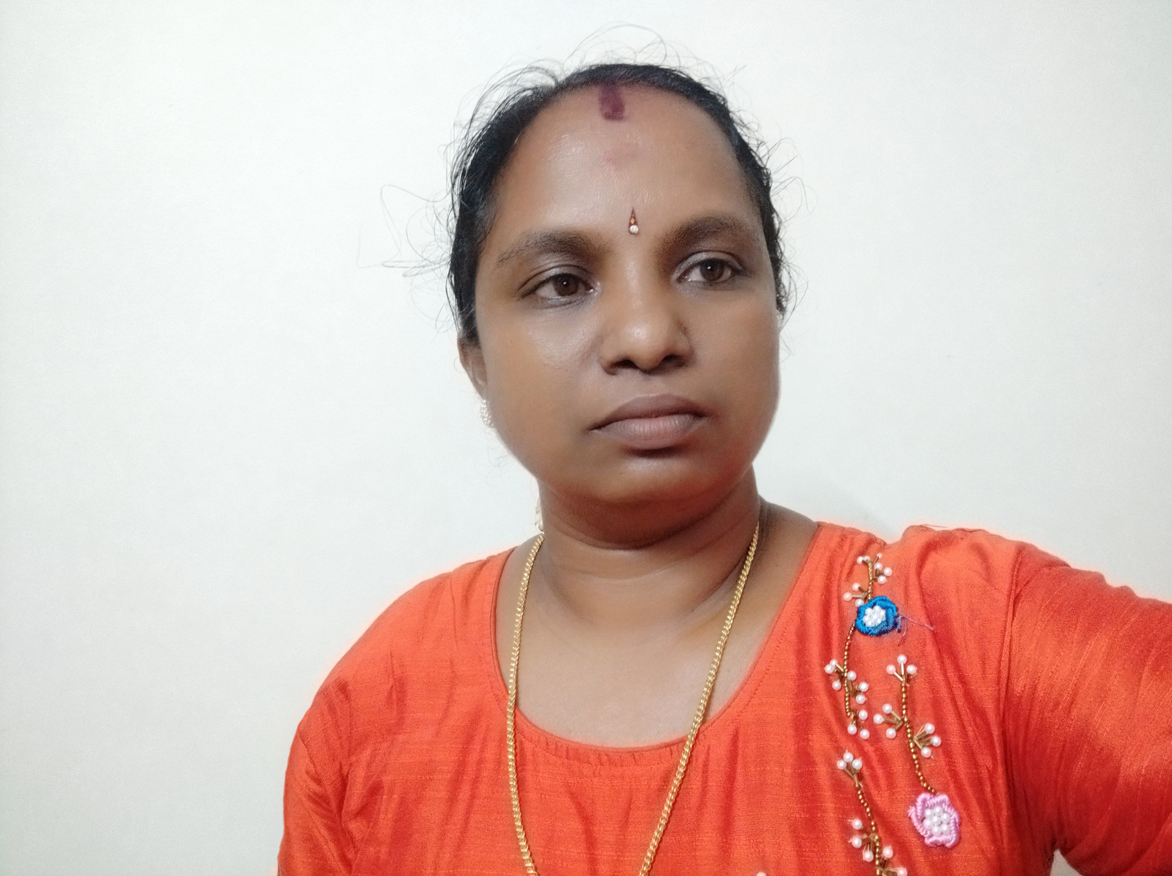

Faculty Name :JAYANTHI,C
Designation :ASSISTANT PROFESSOR
PEN : 449350
Department : HISTORY
Is HOD : NO
Permanent Address :AKSHAYA, KIZHAKKETHARA, MATHUR, PALAKKAD, 678571
Contact Number :9744694158
Email :akshaykrishna2005@gmail.com
Experience Details : as HSST HISTORY 8 YRS 6 MONTHS 4 DAYS
As Assistant Professor-8 years
Educational qualifications
Course | University/ Institution | Year of Pass
UG | MERCY COLLEGE, PALAKKAD, CALICUT UNIVERSITY | 1997
PG | GOVT.VICTORIA COLLEGE, PALAKKAD, CALICUT UNIVERSITY | 1999
M Phil | NIL
Ph D | NIL
Postdoc | NIL
Others (Specify) | B.Edn | 2000

Broad Area of Research : kerala History
Publications(Newest first)
1.
2.
3.

Books/ Chapters Published
1.
2.
Paper Presentations
Sl No | Title of paper | Name of Conference | Date
1
2

Areas Of Interest :

Field of Research :

Research Projects and Grants
Sl No | Title | Funding Agency | Amount Sanctioned | Year
1
2

Research Guideship Details
Number of students registered for Ph D :
Number of students awarded :
Seminars / Workshops Organized
Sl No | Name of the Programme | Venue | Date
1
2

Professional Appointments(Such as Chairman, Director etc)
Sl No | Position | Name of Institution/Body | Date/Year
1
2

Recognition and Awards
Sl No | Name of Award | Agency | Year
1 | BEST PROGRAMME OFFICER –NSS | CALICUT UNIVERSITY | 2017-18
2 | BEST PROGRAMME OFFICER –NSS | CALICUT UNIVERSITY | 2018-19
3 | Certificate of Appreciation –NSS University Project- Abhayam-building home for homeless- | CALICUT UNIVERSITY | 2019

Academic &Administrative Responsibilities
- ADMISSION NODAL OFFICER 2021-22
- SC/ST CELL COORDINATOR 2021-22

Any Other Details to Specify:

