Faculty profile
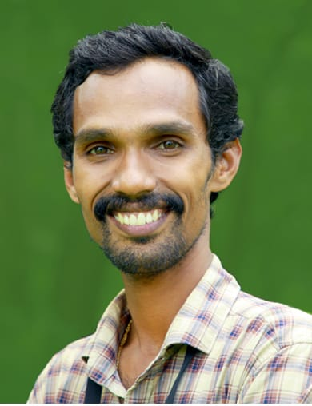

Faculty Name : PRADEESH K.
Designation : Assistant Professor of Commerce
PEN : 646821
Department : Commerce
Is HOD : No
Permanent Address : Kuduvakkode House, Kannadi.P.O., Palakkad- 678701
Contact Number : 974503407
Email : pradeeshkunchu@gmail.com
Experience Details : 8 Years, 6 months
Educational qualifications
Course | University/ Institution | Year of Pass
UG | University of Calicut | 2006
PG | University of Calicut | 2008
M Phil
Ph D
Postdoc
Others (Specify)

Broad Area of Research :Marketing
Publications (Newest first)
Article: Financial Literacy among students in NSS College Nemmara with special reference to Banking and Insurance
Journal : Asia Pacific Journal of Research (Peer Reviewed International Journal) Monthly Journal
Publisher : Asia Pacific Publishing, Bangalore
Impact factor: 6.58
ISSN (Print) : 2320-5504 ISSN (E) : 2347 - 4793
Books/ Chapters Published
1. Chapter: Online Learning and e-Pedagogy
Publisher : UGC-HRDC University of Calicut
ISBN : 978-93-88992-62-6
978000031735
Paper Presentations
Sl No | Title of paper | Name of Conference | Date
1
2

Areas Of Interest :
- Human resource Management
- Entrepreneurship Development
- Cooperation
- Marketing management
- Business management
- Environment

Field of Research :
- Corporate Social Responsibility Practices of Private sector banks in Kerala (MRP)

Research Projects and Grants
Sl No | Title | Funding Agency | Amount Sanctioned | Year
1 | - Corporate Social Responsibility Practices of Private sector banks in Kerala | UGC | 125000 | 2015
2

Research Guideship Details
Number of students registered for Ph D : Nil
Number of students awarded : Nil
Seminars / Workshops Organized
Sl No | Name of the Programme | Venue | Date
1 | nil
2

Professional Appointments (Such as Chairman, Director etc)
Sl No | Position | Name of Institution/Body | Date/Year
1
2
Recognition and Awards
Sl No | Name of Award | Agency | Year
1 | Best State NSS Programme Officer | Government of Kerala | 2018-19
2 | Best NSS programme Officer Award | University of Calicut | 2018-19
3 | Best NSS programme Officer Award | University of Calicut | 2017-18

Academic & Administrative Responsibilities
- Programme officer - National service Scheme (2016-2019)
- Coordinator - Anti- Narcotic Club - (2014-20)
- Member - Stock Verification Committee (2014-2021)
- Coordinator - Entrepreneurship Development Club (2015-16, 2016-17, 2017-18)
- Coordinator – Student study tour (2015-16, 2019-20)
- Coordinator – Red ribbon Club (2016-17)
- Resource Person and Project Guide – School of Distance Education – Contact Classes(2016-17, 2019-20)
- Invigilator - University examination as per allotment (2013-21)
- Staff in charge of department Alumni Association (2016-20)
- Additional Examiner – Valuation of University answer scripts as per allotment (2014-21)
- Invigilator - University examination as per allotment (2014-21)
- Question Paper Setting - Internal Examination, Valuation of answer scripts (2014-21)
- Project Guide and Evaluation –UG and PG (2014-21)
- District Coordinator - Palakkad. National Service Scheme - University of Calicut (2017-2019)
- Coordinator - Cooperative Internship (2019-20, 2021-2022)
- Additional Examiner – Valuation of University answer scripts as per allotment (2018-19)
- Question Paper Setting - Internal Examination, Valuation of answer scripts (2018-19)
- Project Guide and Evaluation –UG and PG (2018-19)
Any Other Details to Specify:
- Best NSS programme Officer Award – University of Calicut – 2017-18
- Best NSS programme Officer Award – University of Calicut – 2018-19
- Best NSS programme Officer Award – Government of Kerala – 2018-19
- Advisory Committee Member Nehru Yuva Kendra – 2016-19
- KDISC – One District One Idea – District Core Team Member

