Faculty profile
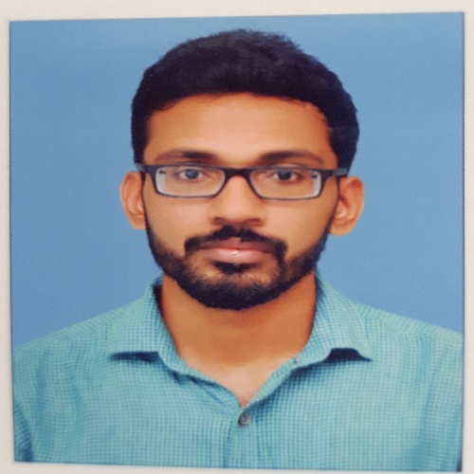
PASSPORT SIZE PHOTO

Faculty Name : Vipin V
Designation : Assistant Professor
PEN :737587
Department : Department of commerce
Is HOD :No
Permanent Address : Melpadam house, Nanniode Po, Palakkad
Contact Number :9746076776
Email : vipinvijayan.vipin@gmail.com
Experience Details :2 years and 6 months
Educational qualifications
Course | University/ Institution | Year of Pass
UG | University of Calicut/ Govt College Chittur | 2009
PG | University of Calicut/ Govt College Chittur | 2011
M Phil
Ph D
Postdoc
Others (Specify)

Broad Area of Research : Marketing
Publications (Newest first)
1.
2.
3.

Books/ Chapters Published
1.
2.

Paper Presentations
Sl No | Title of paper | Name of Conference | Date
1
2

Areas Of Interest :
- Business management
- Marketing management
- Management Accounting

Field of Research :

Research Projects and Grants
Sl No | Title | Funding Agency | Amount Sanctioned | Year
1
2

Research Guideship Details
Number of students registered for Ph D :
Number of students awarded :
Seminars / Workshops Organized
Sl No | Name of the Programme | Venue | Date
1
2

Professional Appointments (Such as Chairman, Director etc)
Sl No | Position | Name of Institution/Body | Date/Year
1
2

Recognition and Awards
Sl No | Name of Award | Agency | Year
1
2

Academic & Administrative Responsibilities
- Covid cell convenor

Any Other Details to Specify:

