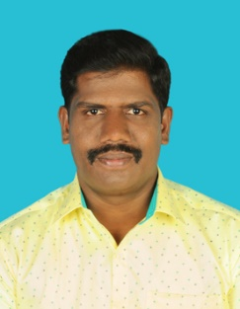
-Faculty profile

PASSPORT SIZE PHOTO

Faculty Name : Dr. Dharmalingam V.
Designation : Assistant Professor
PEN : 868183
Department : Department of Tamil & Research Centre
Is HOD : No
Permanent Address : 3/297, Vaikkalkarai,
Vadachennimalai (Po),
Attur Taluk, Salem Dt, Tamilnadu 636121
Contact Number : 9894450551
Email : atturdharma@gmail.com
Experience Details : 07.09.2021 to till date @
Govt. College, Chittur
04.07.19 – 06.09.2021 @
Govt College, Munnar
2002-2013 @
Non Govt Colleges, Tamilnadu
Educational qualifications
Course | University/ Institution | Year of Pass
UG | Arignar Anna Govt. Arts College, Attur  University of Madras | 1999
PG | National College, Trichy  Bharathidasan University | 2001
M.Phil | Urumu Dhanalakshmi College, Trichy  Bharathidasan University | 2003
Ph D | National College, Trichy  Bharathidasan University | 2012

Broad Area of Research : Modern Literature
Books Published
- பெண்ணிய நோக்கில் ஆனந்தாயி நாவல்
Penniya nokkil Ananthaayi Novel
Aug. 2008, Pallavi pathippagam, Erode
- தமிழ்ப் புதினங்களில் உறவுநிலை
Tamil puthinangalil uravunilai,
Aug. 2008, Pallavi pathippagam, Erode
Chapters Published : 10
Paper Presentations : 12 papers
Areas Of Interest :
- Criticism
- Ancient Literature
- Modern Literature
Field of Research :
- Modern Literature
- Ancient Literature
Research Projects and Grants None
Research Guideship Details Guided 6 M.Phil. Thesis
@ Periyar University
Seminars / Workshops Organized
Sl No | Name of the Programme | Venue | Date
1 | பன்முக நோக்கில் சங்க இலக்கியம்  மூன்று நாள் பன்னாட்டு உரைக்கோவை  தமிழ்த்துறை, அரசுக்கல்லூரி, மூணாறு | இணையவழி | அக்டோபர் 2020

Academic & Administrative Responsibilities
- SC / ST Cell Co-Ordinator 2019-21 @ Govt. College, Munnar

