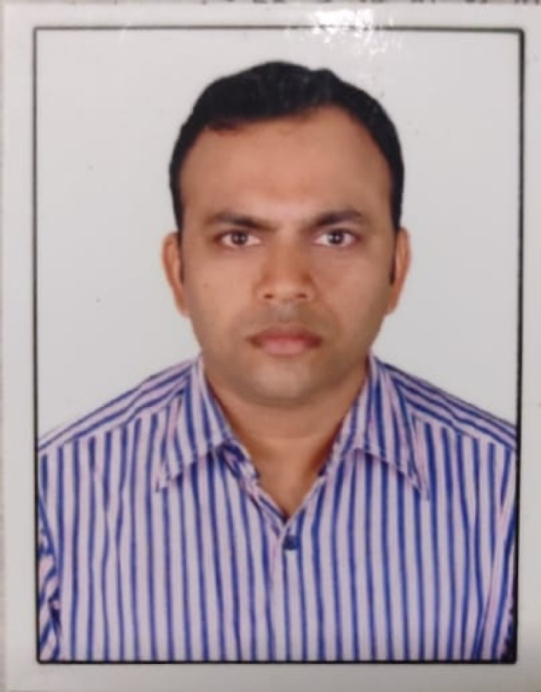
Faculty profile

PASSPORT SIZE PHOTO

Faculty Name : Dr. Prasanth G N
Designation : Assi.Professor
PEN : 594495
Department :Mathematics
Is HOD :No
Permanent Address : Narasimha Mandiram, Sanatanapuram P O, Alleppey - 3
Contact Number : 9447565939
Email :prasanthgns@gmail.com
Experience Details : 17 years in Government and 5 years(approx) in other institutions
Educational qualifications
Course | University/ Institution | Year of Pass
UG | Kerala | 1993
PG | Kerala | 1995
M Phil | Kerala | 1998
Ph D | Kerala | 2010
Postdoc
Others B.Ed | Kerala | 1997

Broad Area of Research : Discrete Mathematics
Publications (Newest first)
30. Prasanth G.Narasimha-Shenoi, Mary Shalet Thottungal Joseph, Center of Cartesian and strong product of digraphs, J. Ramanujan Math. Soc. 36, No.4 (2021) 267–273
29. Kuttikod, S., & Narasimha-Shenoi, P. G. A BRIEF STUDY ON SEMIGRAPHS.
28. Anand, B. S., Dourado, M. C., Narasimha-Shenoi, P. G., & Ramla, S. S. (2021). On the Δ-interval and the Δ-convexity numbers of graphs and graph products. Discrete Applied Mathematics.
27. Manoj Changat, Prasanth G. Narasimha-Shenoi, Mary Shalet Thottungal Joseph, Bijo S. Anand. Boundary-type sets of strong product of directed graphs, Ars Math. Contemp. (2021), doi:10.26493/1855-3974.2229.5f1.
26. Changat, Manoj, Nella Jeena Jacob, and Prasanth G. Narasimha-Shenoi. "Axiomatic Characterization of the Median Function of a Block Graph." Conference on Algorithms and Discrete Applied Mathematics. Springer, Cham, 2021.
​
25. Changat, Manoj, Prasanth G. Narasimha-Shenoi, and Mary Shalet Thottungal Joseph. "Lexicographic Product of Digraphs and Related Boundary-Type Sets." Conference on Algorithms and Discrete Applied Mathematics. Springer, Cham, 2021.
24. Changat, M., Prasanth G. Narasimha-Shenoi., Nezhad, F. H., Kovše, M., Mohandas, S., Ramachandran, A., & Stadler, P. F. (2020). Transit sets of two-point crossover. The Art of Discrete and Applied Mathematics.
23. Anand B.S., Prasanth G. Narasimha-Shenoi, Ramla S.S. (2020) 𝛥-Convexity Number and 𝛥-Number of Graphs and Graph Products. In: Changat M., Das S. (eds) Algorithms and Discrete Applied Mathematics. CALDAM 2020. Lecture Notes in Computer Science, vol 12016. Springer, Cham
22. Anand, Bijo S., Ullas Chandran SV, Manoj Changat, Mitre C. Dourado, Ferdoos Hossein Nezhad, and Prasanth G. Narasimha-Shenoi. "On the Carathéodory and exchange numbers of geodetic convexity in graphs." Theoretical Computer Science (2019).
21. Balakrishnan, Sneha, Sreelakshmi K, and Suresh Kumar K. A, Prasanth G. Narasimha-Shenoi. "Mathematical Interpretation of Aesthetic Value of Floral Structure and Mode of Pollination in Some Angiosperm Plants, LIFE SCIENCES LEAFLETS 115 (2019): 01-11.
20. Changat, M., Prasanth G.Narasimha-Shenoi, Nezhad, F. H., Kovše, M., Mohandas, S., Ramachandran, A., & Stadler, P. F. (2019). Transit sets of k-point crossover operators. AKCE International Journal of Graphs and Combinatorics.
19. Changat, Manoj, Prasanth G. Narasimha-Shenoi, Mary Shalet Thottungal Joseph, and Ram Kumar. "Boundary Vertices of Cartesian Product of Directed Graphs." International Journal of Applied and Computational Mathematics 5, no. 1 (2019).
18. Manoj Changat, Prasanth G. Narasimha-Shenoi and Peter F. Stadler " Axiomatic Characterization of transit functions of weak hierarchies", The Art of Discrete and Applied Mathematics Vol 2(1) 2018.
17. Changat, Manoj, Prasanth G. Narasimha-Shenoi, and Geetha Seethakuttyamma. "Betweenness in graphs: A short survey on shortest and induced path betweenness." AKCE International Journal of Graphs and Combinatorics (2018).
16. Changat, M., Mohandas, S., Mulder, H. M., Prasanth, G. Narasimha-Shenoi., Powers, R. C., & Wildstrom, D. J. (2018). Axiomatic characterization of the center function. The case of non-universal axioms. Discrete Applied Mathematics, 244, 56-69.
15. Changat, M., Mohandas, S., Prasanth, G. Narasimha-Shenoi., Axiomatic Characterization of Anticenter Function of Some Classes of Graphs., AADM
​
14. Changat, M., Mohandas, S., Mulder, H. M., Prasanth, G. Narasimha-Shenoi, Powers, R. C., & Wildstrom, D. J. (2017). Axiomatic characterization of the center function. The case of universal axioms. Discrete Applied Mathematics.
13. Changat, M., Balakrishnan, K., Kumar, R., Prasanth, G. Narasimha-Shenoi., Sreekumar, A. . On the Center Sets of Some Graph Classes. In Algorithms and Discrete Applied Mathematics (pp. 240-253), (2016) Springer International Publishing.
12. Anand, Bijo S., Manoj Changat, and Prasanth G. Narasimha-Shenoi. "Helly and exchange numbers of geodesic and Steiner convexities in lexicographic product of graphs." Discrete Mathematics, Algorithms and Applications(2015): 1550049.
11. Kannan Balakrishnan, Manoj Changat, Anandavally K. Lakshmikuttyamma, Joseph Mathew, Henry Martyn Mulder, Prasanth G. Narasimha-Shenoi, N. Narayanan, Axiomatic characterization of the interval function of a block graph, Discrete Mathematics, Volume 338, Issue 6, 6 June 2015, Pages 885-894.
10. Bijo S. Anand, Manoj Changat, Iztok Peterin, Prasanth G. Narasimha-Shenoi, Some Steiner Concepts on Lexicographic Products of Graphs, DMAA, DOI: 10.1142/S1793830914500608. http://dx.doi.org/10.1142/S1793830914500608
9. M. Changat, A. K. Lakshmikuttyamma, Joseph Mathews, Iztok Peterin, Prasanth.G. Narasimha-Shenoi, Geetha Seethakuttyamma, Simon Špacapan, A forbidden subgraph characterization of some graph classes using betweenness axioms, Disc. Math.,313,(2013), 951–958.
8. M. Changat, A. K. Lakshmikuttyamma, Joseph Mathews, Iztok Peterin, Prasanth.G. Narasimha-Shenoi, Aleksandra Tepeh,A note on 3-Steiner intervals and betweenness,Disc Math, 311, (2011), 2601–2609.
7. Changat, Manoj; Prasanth G. Narasimha-Shenoi.; Pelayo, Ignacio M., The longest path transit function of a graph and betweenness. Util. Math. 82 (2010), 111–127.
6. M. Changat, J. Mathews, Prasanth.G. Narasimha-Shenoi, I. Peterin,n-ary transit functions in graphs, Discussiones Mathematicae Graph Theory 30, 4(2010), 671-685.
5. Boštjan Brešar, Manoj Changat, Joseph Mathews, Iztok Peterin, Prasanth G.Narasimha-Shenoi, Aleksandra Tepeh Horvat; Steiner intervals, geodesic intervals, and betweenness; Disc. Math., Volume 309,(20): 6114–6125 (2009).
4. B.Brešar, M. Changat, S.Klavžar, J. Mathews, A. Mathews, Prasanth. G.Narasimha-Shenoi, Characterizing posets for which their natural transit functions coincide,ARS MATHEMATICA CONTEMPORANEA 2 (2009) 27–33
3. Manoj Changat,G.N. Prasanth, Joseph Mathews, Triangle path transit functions, betweenness and pseudo-modular graphs, Disc. Math. 309 (2009), pp. 1575-1583
2. Prasanth G. Narasimha-Shenoi,On a Metric related Transit Function and its Betweenness,In: Convexity in Discrete Structures (M. Changat, S. Klavžar, H.M. Mulder, A. Vijayakumar, eds.), Lecture Notes Ser. 5, Ramanujan Math. Soc. (2008), 83–90
1.K. Balakrishnan, M. Changat, S. Klavžar, J. Mathews, I. Peterin, Prasanth G.N. and S. Sˇpacapan,Antimedian graphs, Australasian J. Combinatorics, 41(2008) 159- 170

Books/ Chapters Published
1.
2.

Paper Presentations
Sl No | Title of paper | Name of Conference | Date
1 | A study of betweenness and transit functions | Slovenia | 2007
2 | A brief introduction to transit functions | Germany | 2013

Areas Of Interest : Linear Algebra, Discrete Mathematics

Field of Research : Graphs Digraphs, Convexities and Some related ideas.

Research Projects and Grants
Sl No | Title | Funding Agency | Amount Sanctioned | Year
1 | A study of convexity parameters, l_p -functions, Steiner sets and related problems on Graphs | SERB | 660000 | 2019
2 | A Study on axiomatic characterizations, convexity and distance related problems on graphs and its products and, Graphs arising from Rings | SERB | 660000 | 2017
3 | Computational Algorithmic graph theory and Random Graphs (Co-PI) | KSCSTEC | 1128600 | 2016
4 | A study of metric relarted transit functions on graphs, digraphs and hypergraphs | UGC | 145000 | 2011
5 | A Brief Survey of Mathematical Applications in Other Subjects | KSCSTEC-SPYTIS | 10000 | 2017
6 | Axiomatic Characterizations of anticenter function of some graph classes | KSCSTEC | 10000 | 2018

Research Guideship Details
Number of students registered for Ph D :1
Number of students awarded :1
Seminars / Workshops Organized
Sl No | Name of the Programme | Venue | Date
1 | HSSTTP | GCC | 2018,2019
2

Professional Appointments (Such as Chairman, Director etc)
Sl No | Position | Name of Institution/Body | Date/Year
1
2

Academic & Administrative Responsibilities
1 Member of Editorial Board of online flip magazine Vayanadinam
2 CLASS TUTOR UG

Any Other Details to Specify:

