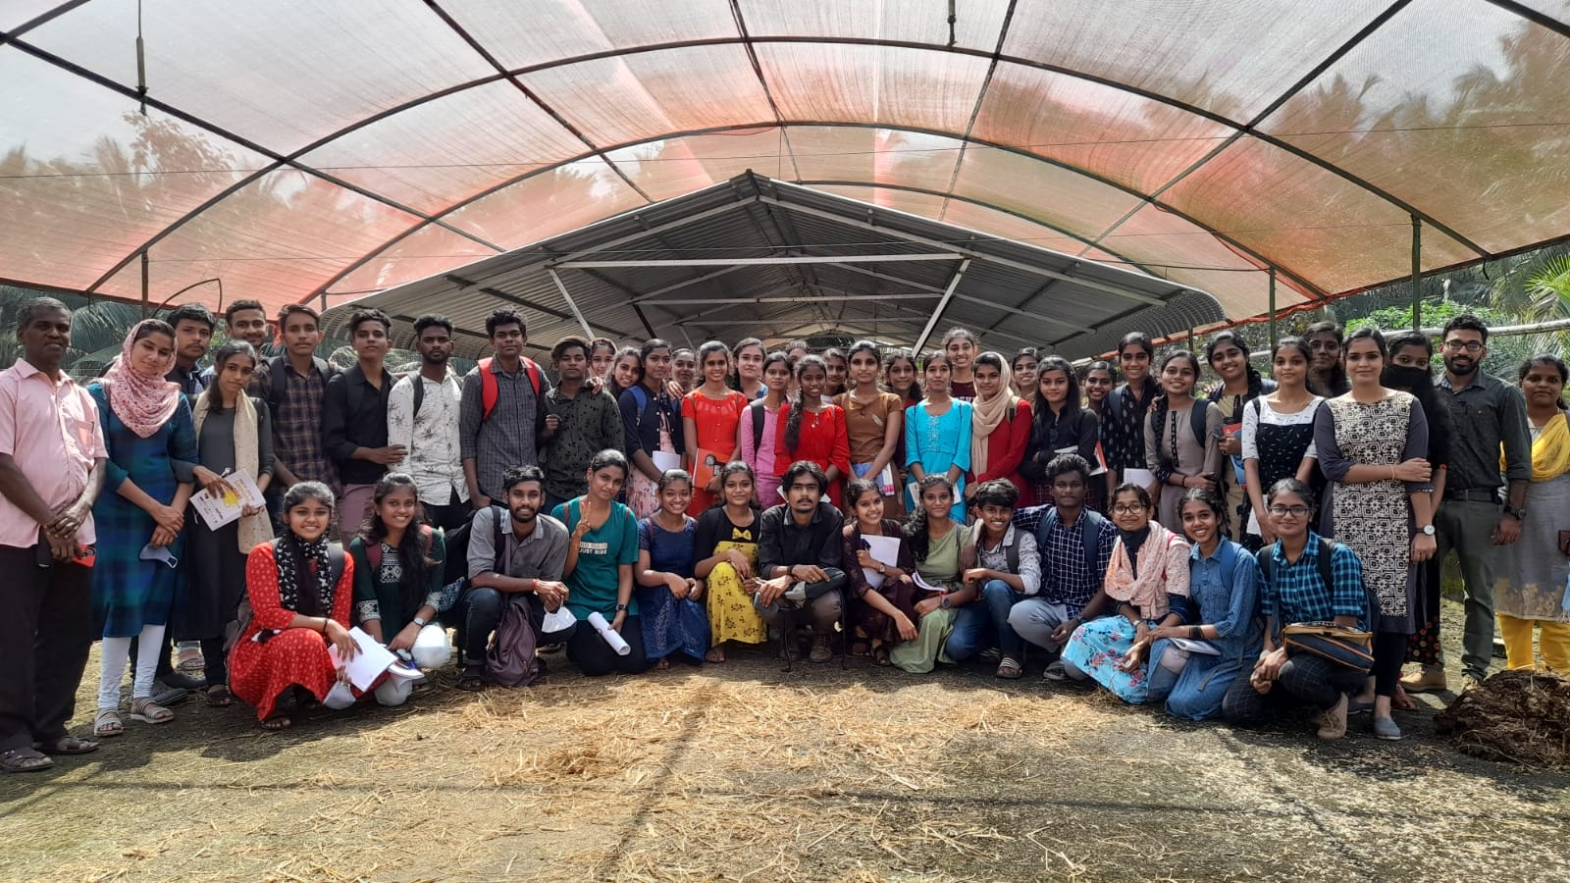Entrepreneurship development club
Entrepreneurship development club formed in colleges to inculcate entrepreneurship qualities among youngsters to sensitize present industrial scenario and nurture the latent entrepreneurial talent and develop awareness among its members. It is functioning with the intention of creating values, skills, techniques and confidence for successful entrepreneurs.
OBJECTIVES of the club
- To inculcate entrepreneurial culture and qualities among students
- To make them aware of unlimited developmental potential of the state.
- To motivate members on various dimensions of industry to nurture the latent entrepreneurial talents
- To induct entrepreneurial spirit in institution
- To sensitize students on the real economic and industrial development scenario of the state
Coordinator (2021-2022) Ms. LEENA T U , Department of Commerce.
Members
- Dr. M P Lekshmanan (commerce)
- Ms. Jayanthi (history)
- Mr. Sarin (electronics)
- Ms. Savitri (music)
- Ms. Ruby (mathematics)
- Dr. fathima (tamil)
- Ms. Saritha (Malayalam)
- Dr. Roobina (Geography)
- Dr. sheenuja (Hindi)
- Dr. Manju Varghese (economics)

Annual events
- Awareness programs with distinguished guest speakers associated with DIC Palakkad
- Visits to industries , firms and face to face interactions with entrepreneurs
- Networking with successful entrepreneurs, startup joiners and investors
- Organizes quiz competition programs based on entrepreneurship activities
- To familiarize the youth to the latest developments through media.
- Conducting ED Fest

ACTIVITY 1
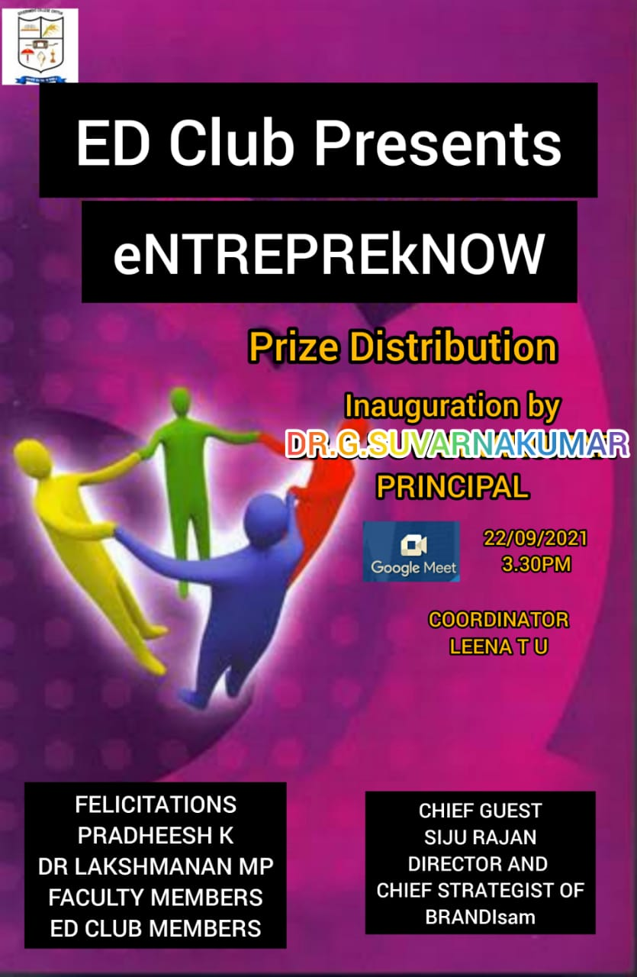
Online business quiz competition
ED Club conducted a intercollegiate online business quiz competition named “ eNTREPREkNOW “ on 22/09/2021 at 3.30 PM to 4.30 PM ,having five rounds including personality identification round, logo identification , advertisement creation round ,promotion video round etc.. 18 students from various departments are registered and actively participated. Winners – cash price for first shared by two students Sharfiya M (commerce ) and Abhijith S (electronics), second price is for Hibanaz(electronics) Prize distribution inaugurated by respected principal Dr.G.Suvarnakumar . The program chief guest was Mr.Siju Rajan The Director and Chief strategist of BRANDIsam, Dr.MP Lekshmanan Head of the department of commerce ,Mr. Pradeesh K Assistant Professor are given felicitations.

ACTIVITY 2
Entrepreneurial Awareness seminar
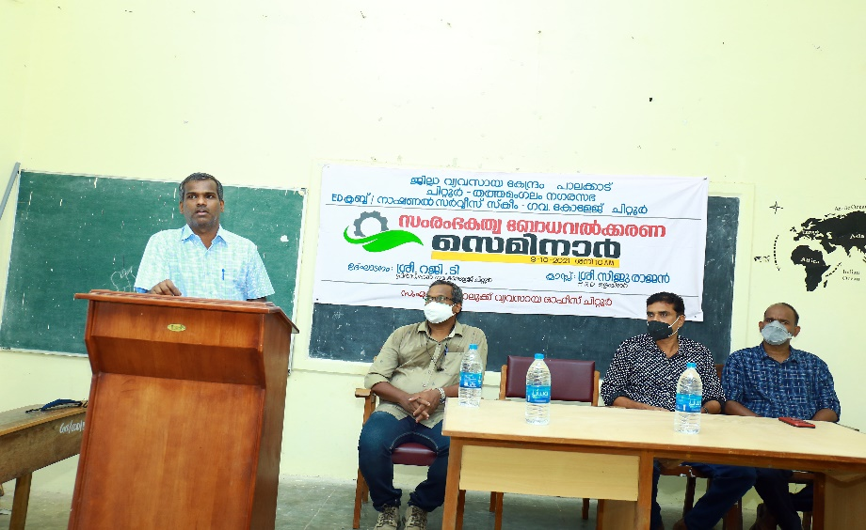
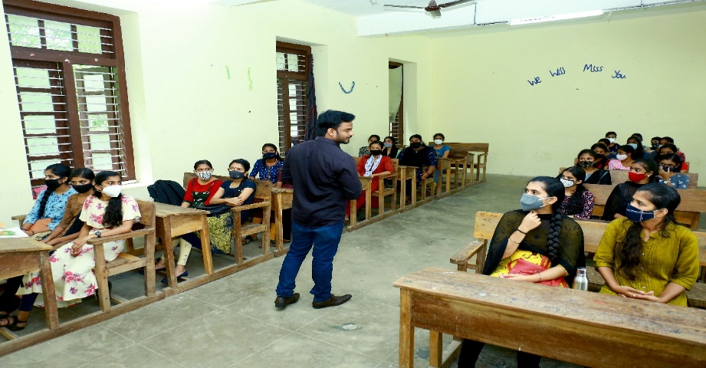

Awareness seminar organized by District Industrial Centre Palakkad in association with ED Club and NSS Unit of Government college Chittur. The inaugural session was held on 9/10/2021 at 10 AM at MG Hall and inaugurated by Dr. MP Lekshmanan Principal in charge. Session handled by Mr.Siju rajan HRD Trainer.

ACTIVITY 3
INDUSTRIAL VISIT
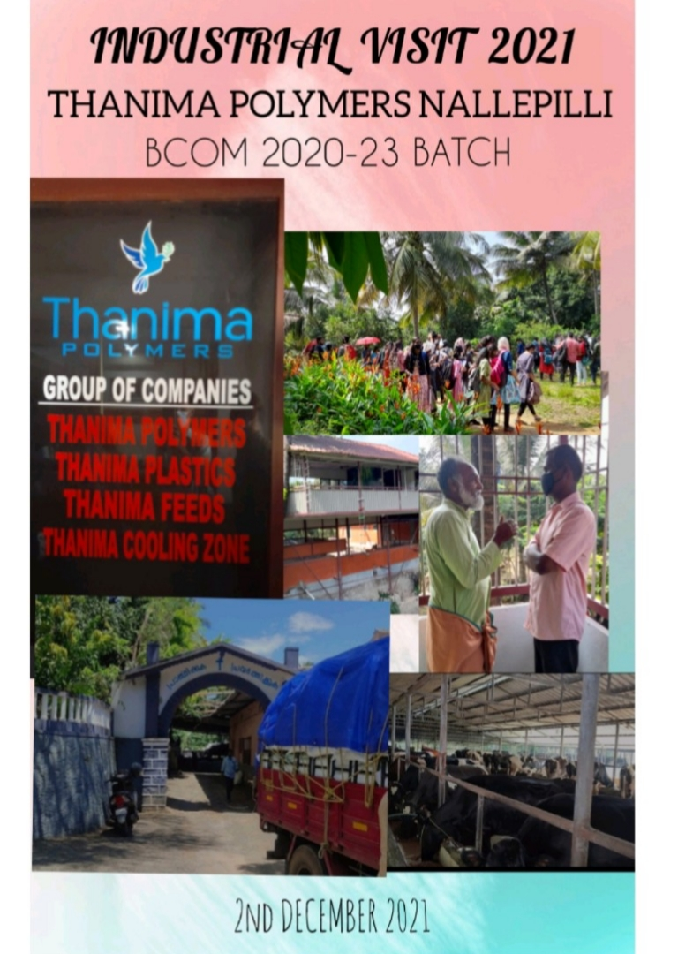
An industrial visit conducted by Commerce department in association with ED CLUB on 02/12/2021 in THANIMA POLIMERS Group of company NALLEPILLY with B.COM students . Students are Escorted by Dr. MP Lekashmanan HOD Commerce, Mr.Pradeesh K Asst.Professor of Commerce , Mr.Vipin V Asst.Professor of commerce and Mrs. LEENA T U Asst.Professor of commerce and Coordinator of ED CLUB. THANIMA is a group of companies such as THANIMA POLYMERS , THANIMA PLASTICS,THANIMA FEEDS and THANIMA COOLING ZONE. Industrial Visit coordinated by Richard scaria ,Assistant Professor of Geography Department and students got awareness on multi crop system in agriculture, Farm and Tourism opportunities ,Fisheries and Animal Husbandary, Waste disposal and Management, Government schemes and financial assistance of THANIMA products and Polymer Industry .It was a wonderful experience and inspiration for the whole team.

