BHOOMITHRASENA CLUB
(BMC – 187/PKD/10/12)
GOVERNMENT COLLEGE, CHITTUR, PALAKKAD
Activity Report
(1st April 2022 to 31st March 2023)
The activities of Bhoomithrasena Club in Chittur Govt. College campus were started in the March of 2013. Students, teaching and non- teaching staff are actively participating in all the activities organized by Bhoomithrasena Club. We have organized activities for the conservation of environment and awareness creation on nature and natural resource utilization. At present more than hundred students are enrolled as the members of Bhoomithrasena Club. In our college. Sri. Suresh Kumar KA, HoD and Asst. Professor, Dept. of Botany is the Faculty in Charge (FIC) of Bhoo Mithrasena Club. Kum. Ashimna Shamsudheen (III Year B.Sc. Botany) is in charge of student co- coordinator.
WORLD ENVIRONMENT DAY CELEBRATION – (7th June 2022)
In this occasion, on 6th June 2019, BMC members sowed seeds of various indigenous fruit yielding trees in the college campus. In connection with this a talk by was also organized on the same day and it was done by Dr. BINUMOL M, Asst. Professor, Department of Botany, S N College, Alathur on the topic “Conserve the Nature for Future”.
WORLD OZONE DAY CELEBRATION (16th September 2022)
“OZONE- Myth and Reality” - Short film show on ozone layer was organized to create awareness on necessity of ozone layer in protecting the living system in the earth. Dr. DAMODARAN P N, HoD, Solid Waste Management, IRTC, Mundur delivered a talk on “Role of Solid Waste Management in Protection of Ozone Layer”.
WORLD SOIL DAY ( 5th December 2022)
Sri. SURESH S ONURPALLAM, Regional Advisory Board Member, NABARD and Director, Palakkad Sammisra Krshaka Producer Company has conducted a class on Organic Farming and delivered talk on “Holistic Approach of Organic Farming” and shared his field level experience on organic farming and soil conservation.
TRAINING ON MUSHROOM CULTIVATION & ZERO WASTE MANAGEMENT (11th January 2023)
Edible variety of mushroom namely Oyster mushroom (Pleurotus sajor-caju) were cultivated by utilizing the various types of agro wastes collected from different areas of Chittur Thathamangalam Municipality. The agro wastes utilized for preparation of beds for mushroom cultivation includes wastes from paddy, banana, etc. The waste from mushroom cultivation was used for the production of compost. SURESH KUMAR KA, HoD, Dept. of Botany, Govt. College Chittur and S GURUVAYURAPPAN have taken classes in the training programme. 30 Students participated in the training programme. This programme held on 11th January 2023.
WORLD WETLAND DAY CELEBRATION (2nd February 2023)
Dr. SURESH V, Asst. Professor, Dept. of Botany, Govt. Victoria College Palakkad has taken a class on “Wetland the Wonderland” and explored the biodiversity of Sokanasinini River.
ORGANIC FARMING
Vegetable garden is maintaining for the production of organic vegetable and providing training on organic farming.

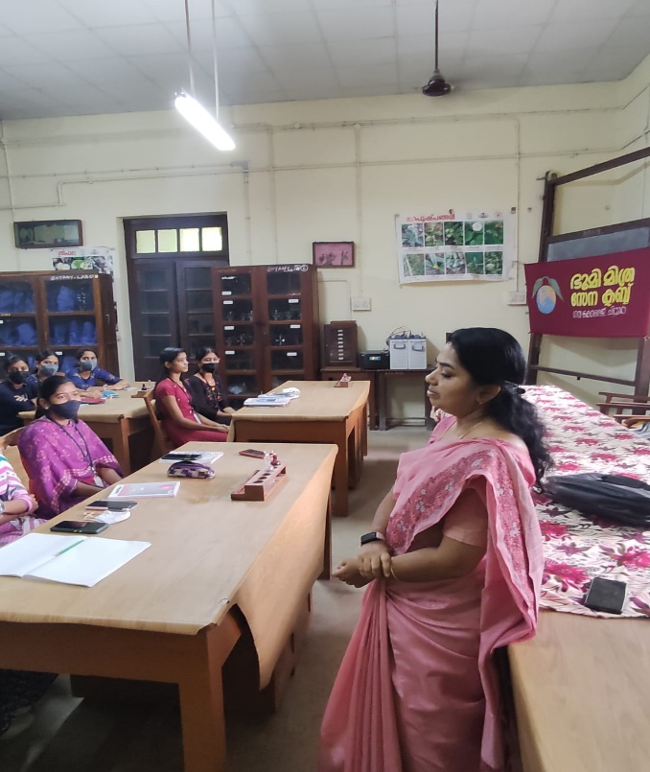 | 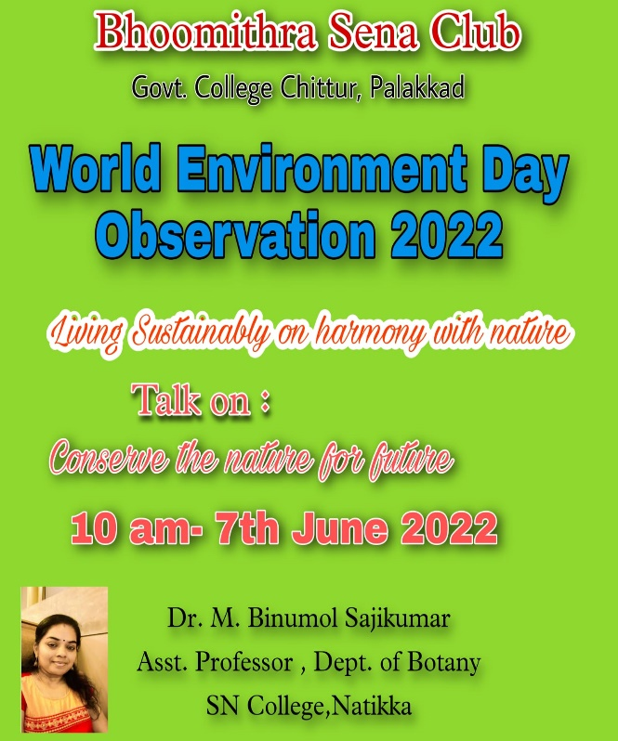
Dr. BINUMOL M
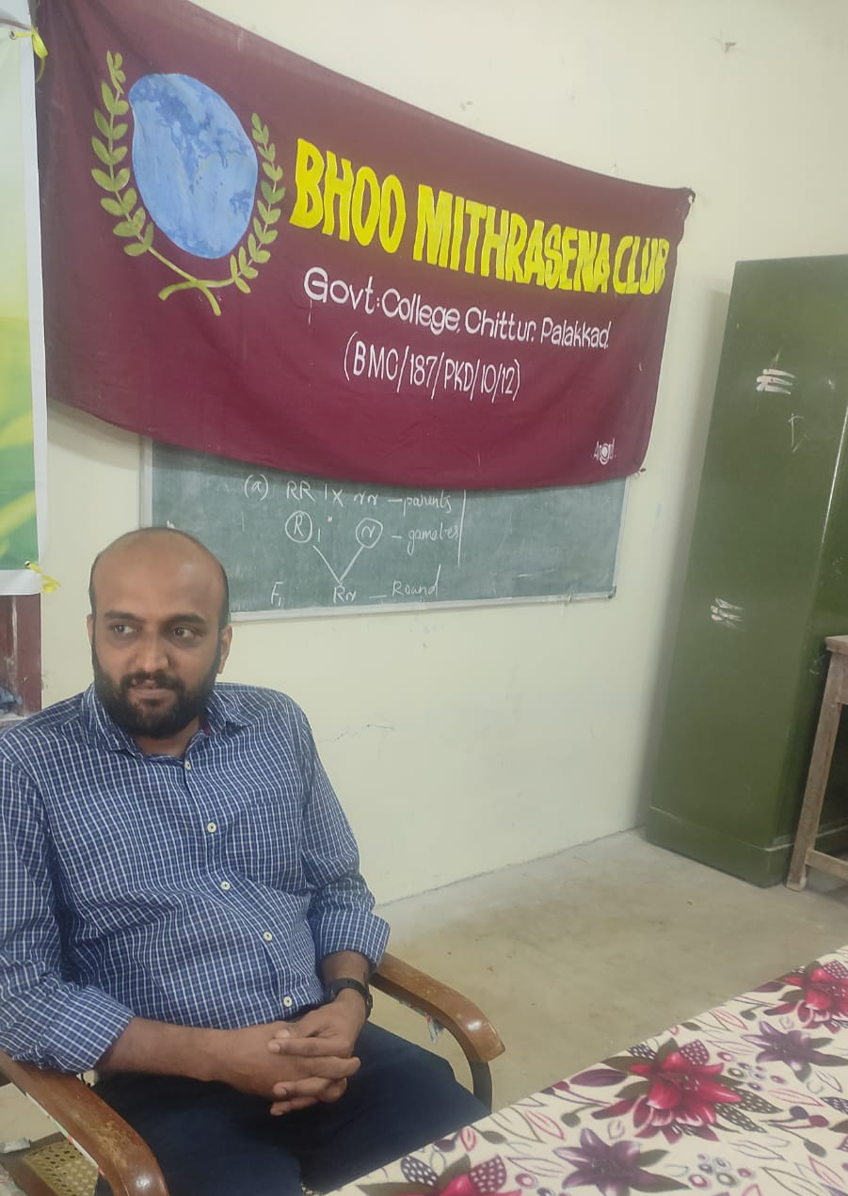 | 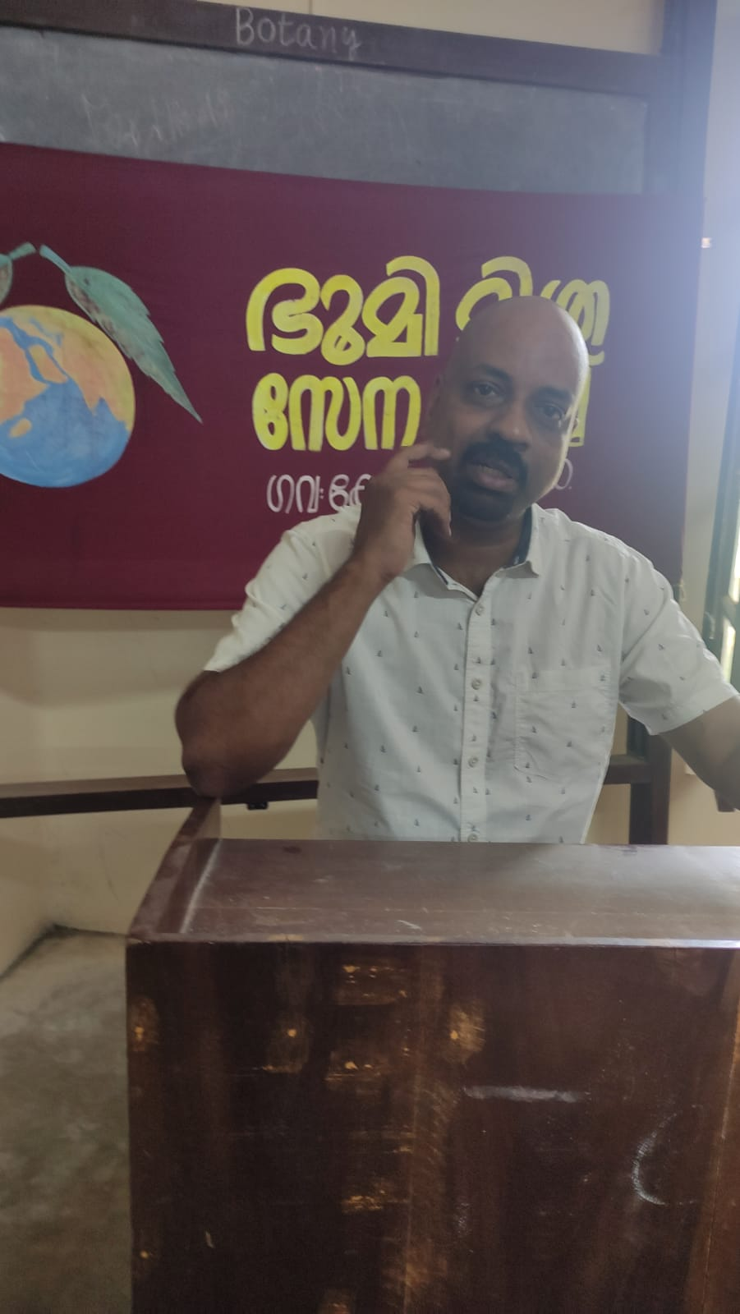
Dr. SURESH V | Dr. DAMODARAN P N
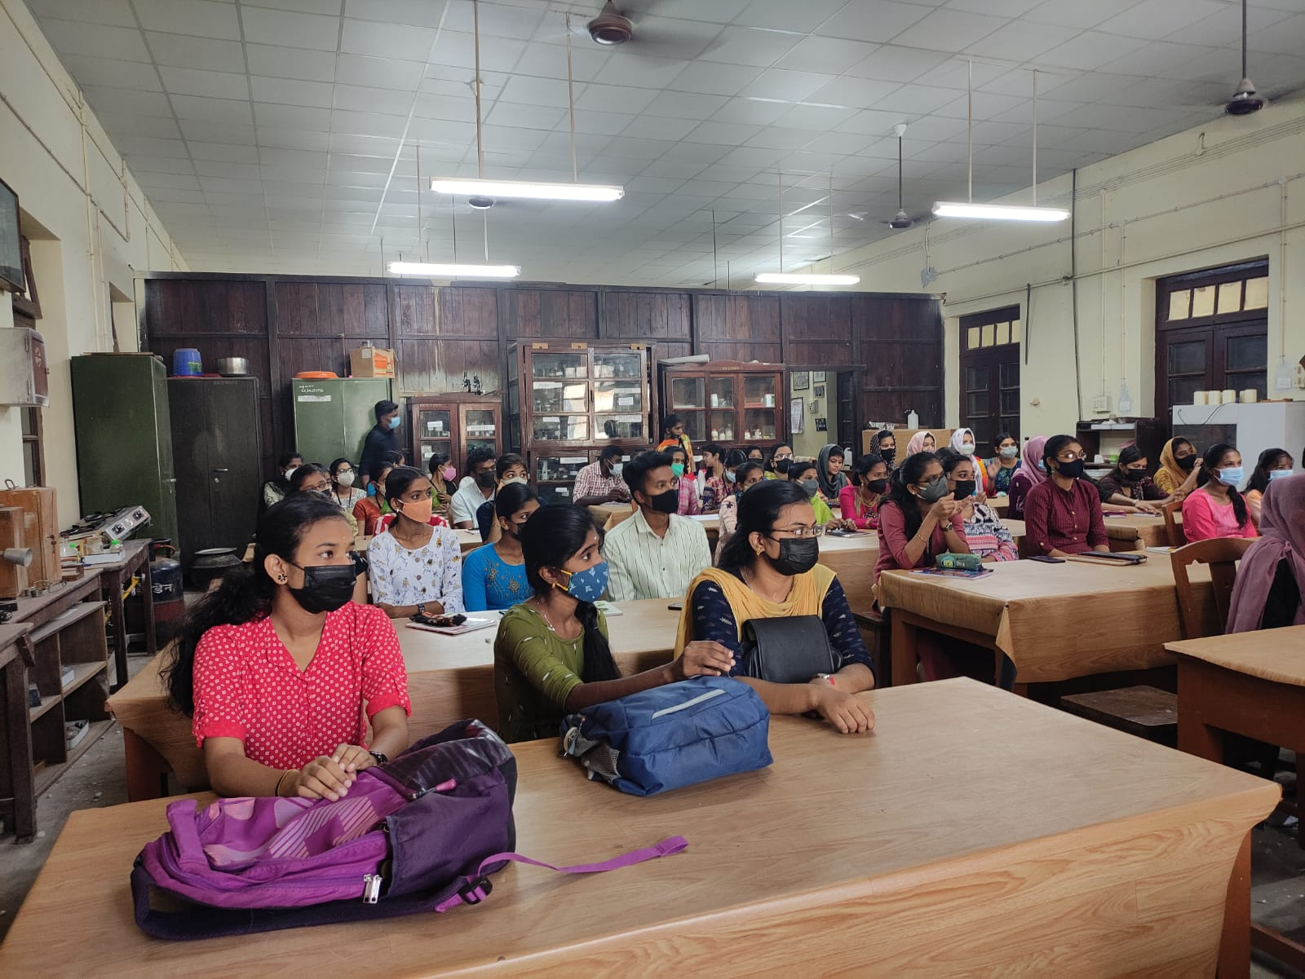 | 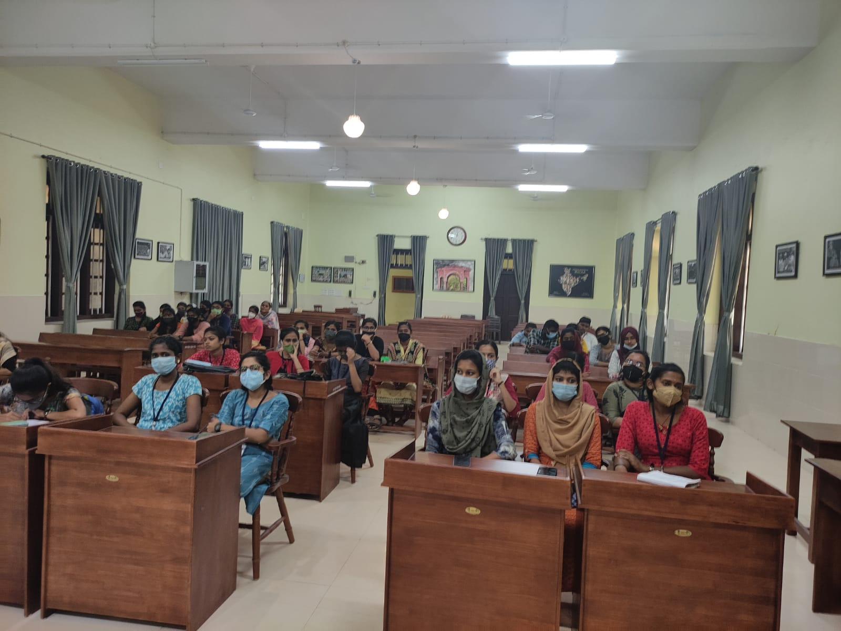
PARTICIPANTS
 | 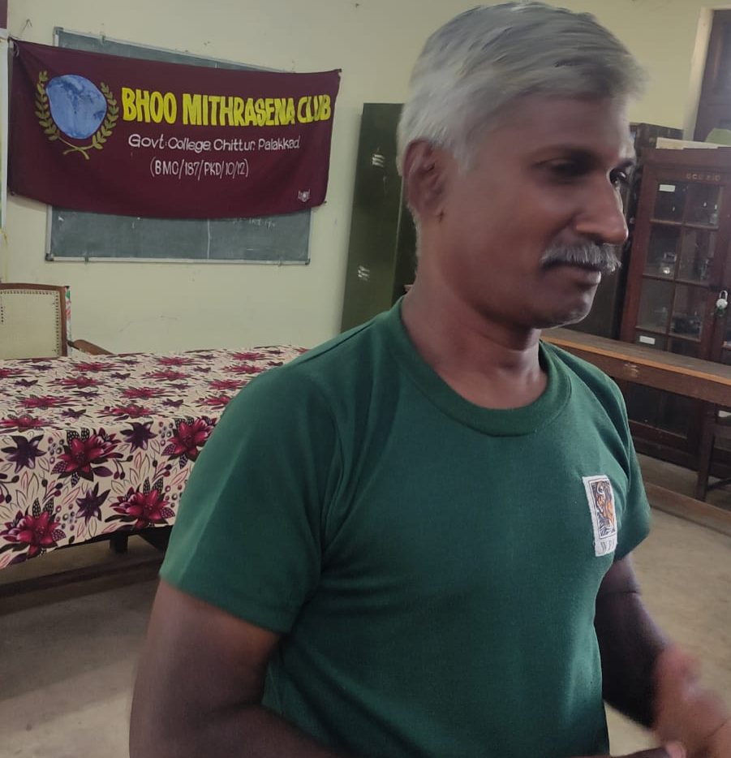
SURESH S ONURPALLAM, | S. GURUVAYURAPPAN
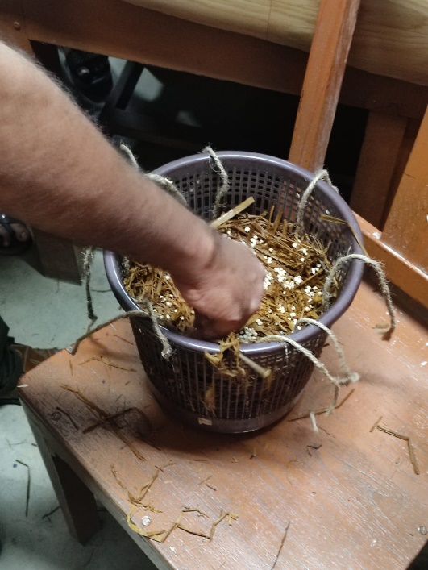 | 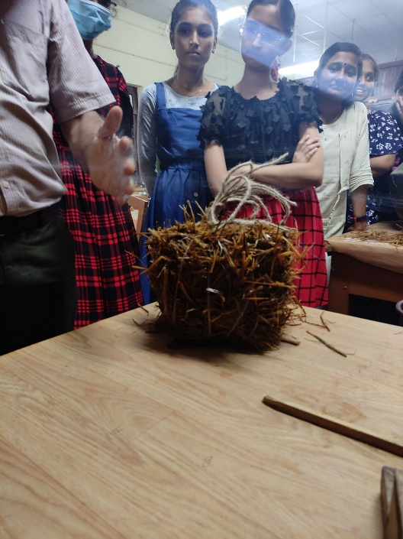
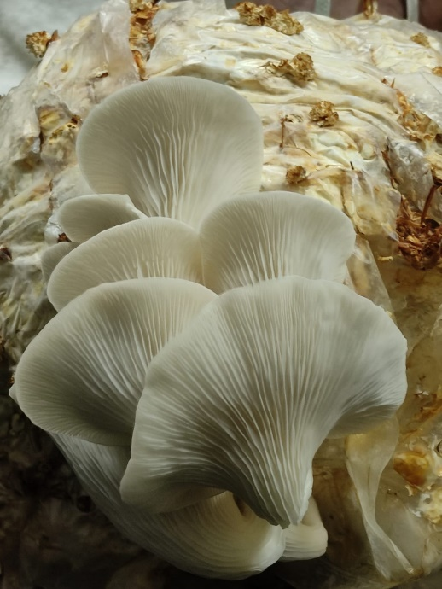 | 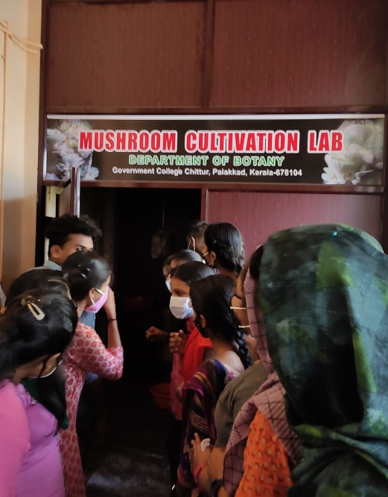
TRAINING ON MUSHROOM CULTIVATION ANG PRODUCTION OF COMPOST

