Career Guidance and Placement Cell
Report for the year 2022-2023
The Career Guidance and Placement Cell aims to create awareness about various
job opportunities and career options available to the students. The cell actively provides assistance to the students by conducting seminars, workshops etc. The activities of the cell for the academic year 2022-2023 officially started with the inaugural function on 16th December 2022. Dr Rajoo Krishna S, Former Deputy Director, Kerala inaugurated the function at 10 am. The principal, Dr. V K Anuradha presided over the function. Vice
Principal Dr. K Baby, Sri. Manu Chakaravarthy, PTA Secretary, Murukan, Jubilee Celebration Convener, VIjayakrishnana M, IQAC Cordinator and Akshay, Union Chairman also shared their thoughts on the occasion. One day workshop on “Career Guidance Programme conducted on 16th Dec 2022. Dr Rajoo Krishna handled the introductory session and career class. He emphasized the need for career Planning and talked on various career opportunities available in government and Private sector.
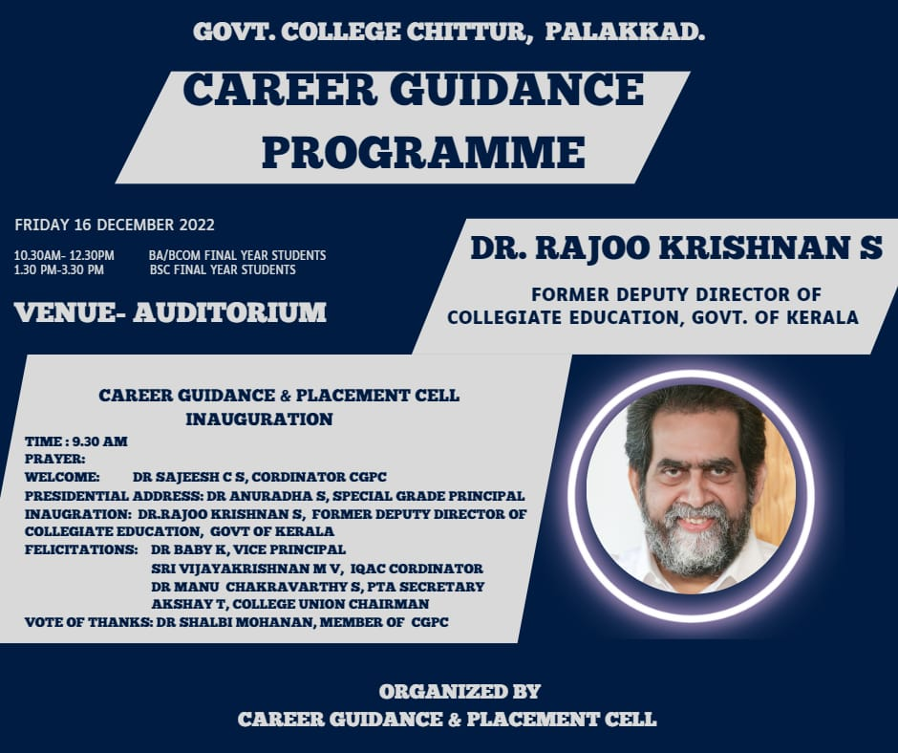

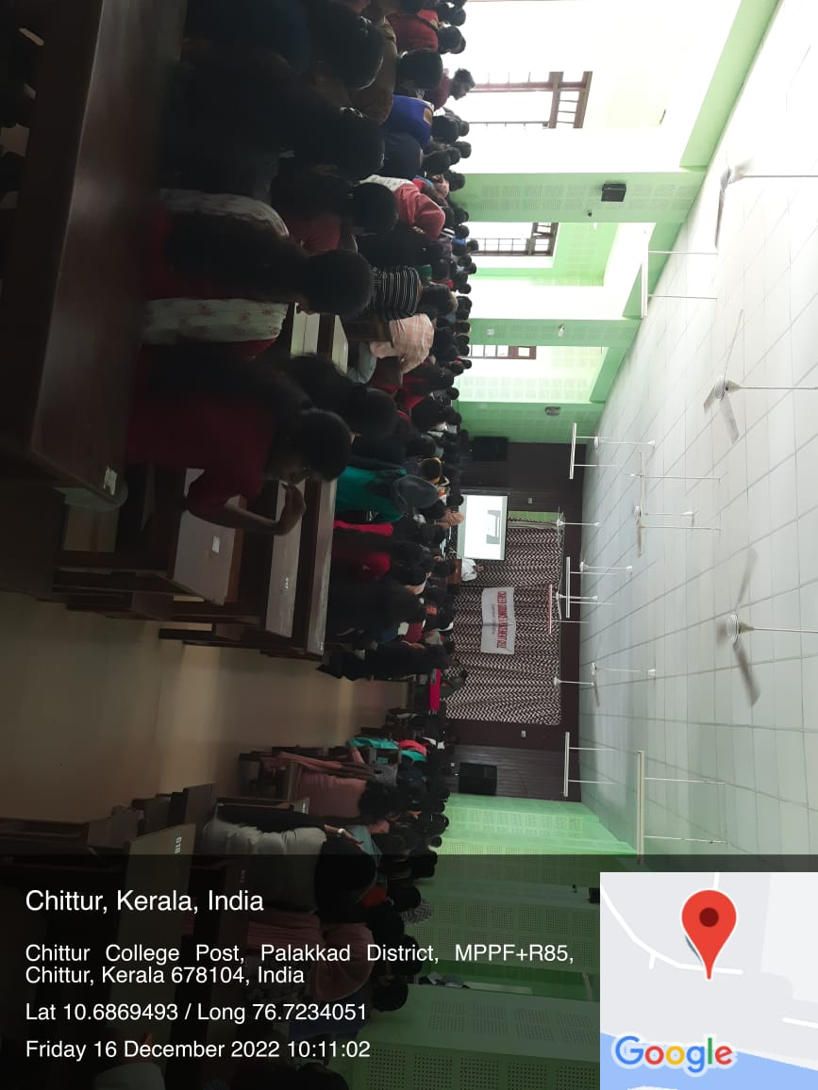

A seminar on Skill Development Programme was organized on 28 Feb 2023. Naveen, Manager of IDD Institute of Management& Science Pvt Ltd, handled a motivational session and Motivation Trainer Smt Deepa Jayaprakash explain how to clear and approach the Various examinations easily. The highlight of the seminar was an interaction session with Students, from various Departments. She shared his experiences and thoughts with patiently and clarified the doubts and curiosity of the students. Around 100 students were benefited by this seminar.

