Government College Chittur
Palakkad – 678 104
------------------------------------------------------------------------------------------------------------------------
JEEVANICENTRE FOR MENTAL HEALTH
AND WELL-BEING
2022-2023
Web : https://chitturcollege.ac.in/ | Email : club/cell official email id
======================================================
List of programmes conducted in the academic year YYYY-YYYY (June 1 to May 31)
SL | Title of the  programme | Type (Seminar/  Debate/ Poster  presentation /  Workshop /  Camp etc | From | To | Convernor/  Coordinator  with  department
1 | Jeevani counsellorAnjana C P was appointed on October 25,2022 |  |  |  | Dr.SREEJA K T  Dept.of Music
2 | Room was acquired for Jeevani
3 | Awareness class was conducted on all classes about the jeevani counselling services
 | Poster was prepared about jeevanicounseling that will help to reach out directly among the students very immensely | 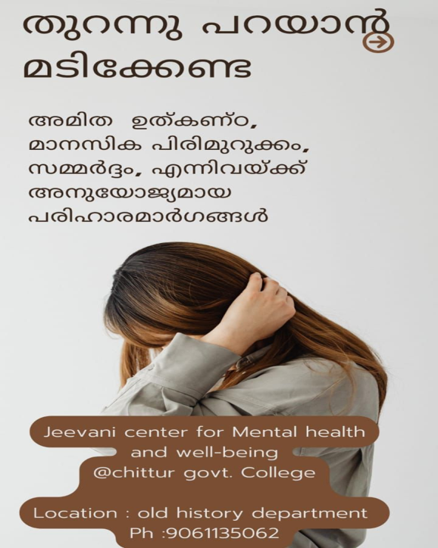  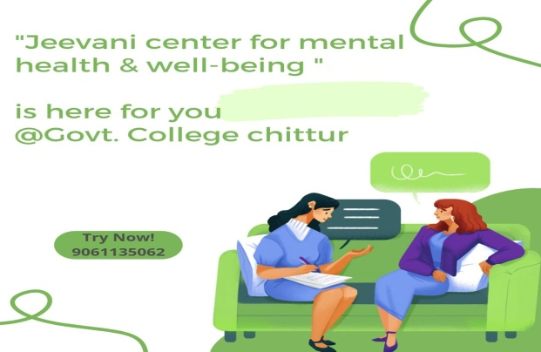
 | On 25th November official meeting was conducted on google meet about the further developments and functions of jeevanicenter for mental health and well-being programme.presidential address was done by Principal  Dr.Anurada V.K. the chief guest was clinical psychologist SarathSundar. | 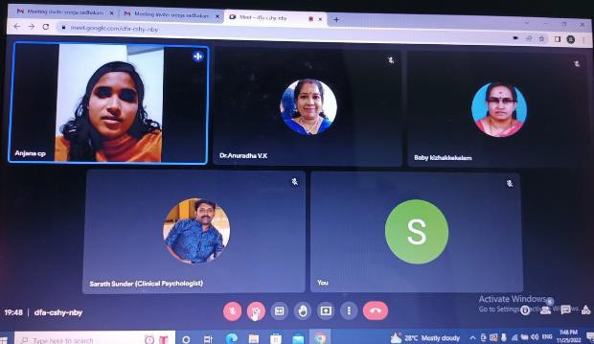
 | The inauguration of jeevani centre for mental health and well-being wass done on November 30 Wednesday on M.G hall, inaugurated by psychologist VijithaPremsundar. | 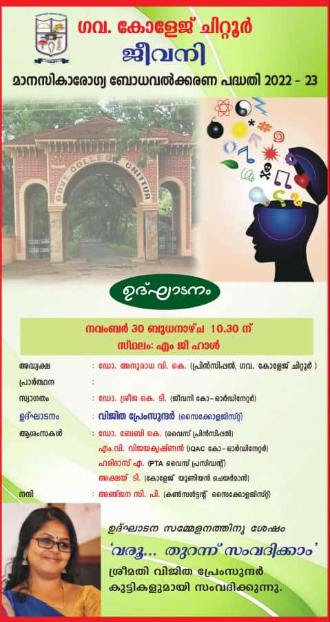
 | The inauguration of jeevani mental health programme is reported by mathrubhumi newspaper on 1/12/2022. | 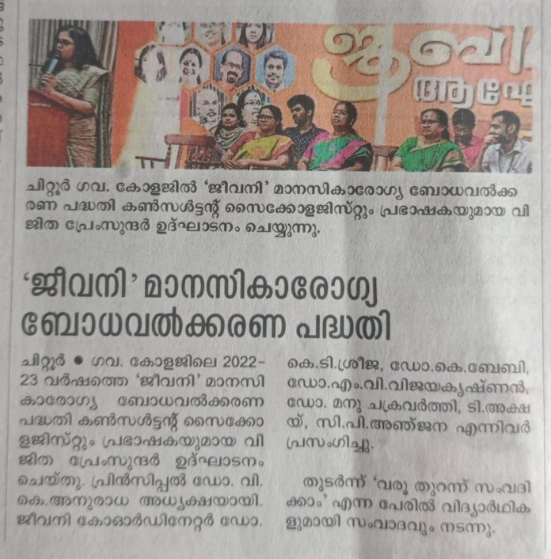
 | Shot film contest was called for GCC students on the theme” happiness day” which brings out a positive attitude among students | 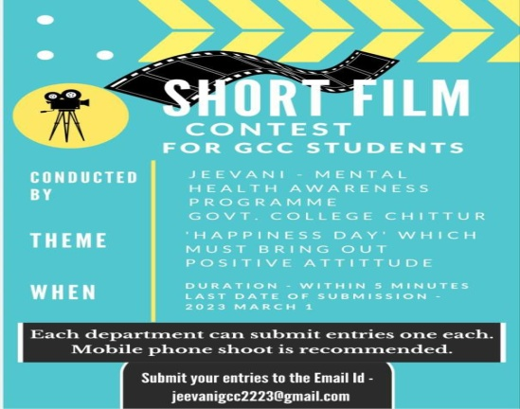
 | Public poster was circulated as a reminder of international day of happiness to put it on as status.
 | Total 77 cases were reported from 25th October to march 30. Different types of cases were reported from the very short period of time. | Individual Counselling | 25-10-2022 | 30-03-2023

Name & Signature of the department head/ Co-ordinator

Certified that the details of all the programmes listed above have been
received by the IQAC in in proper format .

IQAC Coordinator
(Name)
Chittur
(Date)
Note : A copy of this is to be retained by the IQAC co-ordinator.

