NATURE CLUB
GOVERNMENT COLLEGE CHITTUR
ACTIVITY REPORT 2022-23
The activities of Nature club of Government College, Chittur was commenced on 20-10-2023 with an inaugural function presided over by Suresh Kumar K.A, HoD, Department of Botany, Government College, Chittur and inaugurated by Dr. Anuradha V.K, Principal, Government College, Chittur. The theme of Nature club for the year 2022-23 was selected as “Let’s Stand For Nature”. The club has 84 registered members of various departments of the college. As a part of creating a plastic free campus, several initiatives were taken over by the club. One of such programmes was “Pick and Plop Down the Plastic Pens”, which was an interdepartmental competition to collect maximum number of unusable plastic pens from the campus premises. It was on 31/10/2022 and was a successful event. Department of Physics of our college won the crown. The programme was done in association with the Environmental club and Green Protocol Committee of the College. Another such programme was on the theme “Let’s reuse plastic bottles”. As a part of it, members of the club collected disposed plastic bottles from college premises and used them for potting garden plants and used to beautify the department. An interdepartmental photographic competition was conducted named “Just me and my buddy” which was for pet lovers of the campus. On 20th January 2023 Sri.S. Guruvayurappan, Wild Life Protection and Conservation Society, Kerala, interacted with students and shared his field level experience in conservation and man animal conflict and delivered a talk on “Role of waste management in conservation”. Nature club organized a nature camp at Thattekkad Bird Sanctuary from 24/03/2023 to 26/05/2023, in which 18 UG students participated. The participants got the chance to understand and experience nature at its best.
Nature club Inauguration
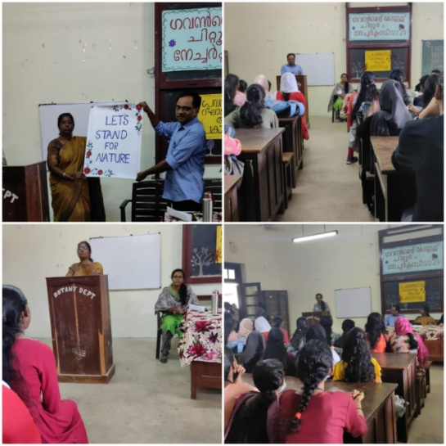

Nature camp 2022-23
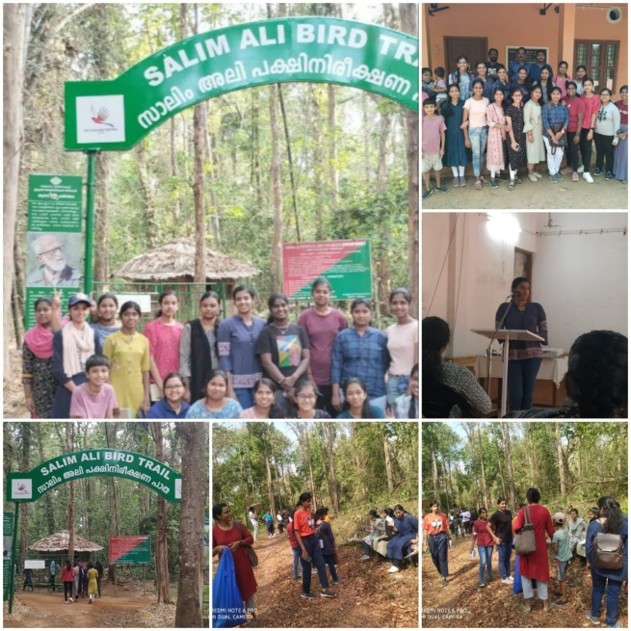

‘Let’s reuse plastic’ campaign
