Red Ribbon Club
Report for the year 2022-2023

The Red Ribbon Club is a voluntary intervention program for students in educational institutions. It is initiated and supported by the Kerala State AIDS Control Society and implemented through Higher Education Department. It is aims to create awareness among the students on AIDS and promoting them for blood donations.
Activities
- College Level Quiz Competition. (25/10/2022 )
A College Level Quiz Competition was conducted on the topic ,HIV awareness and prevention. 27 students participated. The first and second place winners were selected for the district level competition.

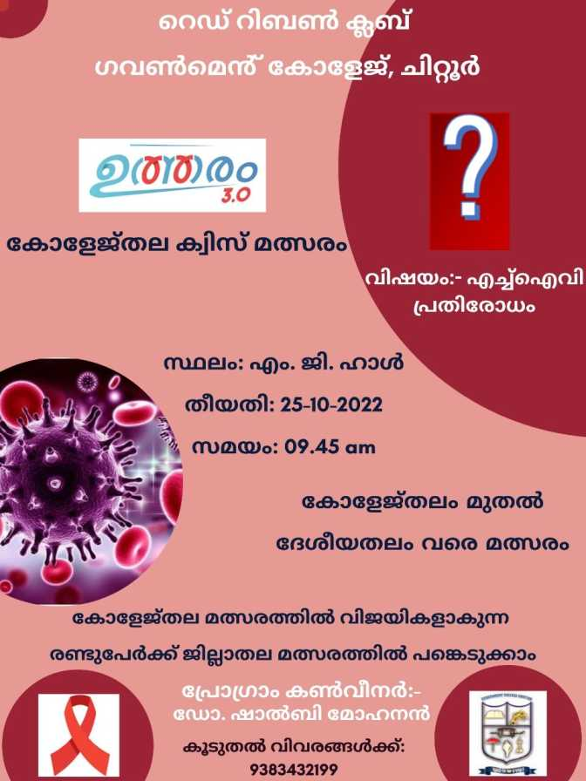
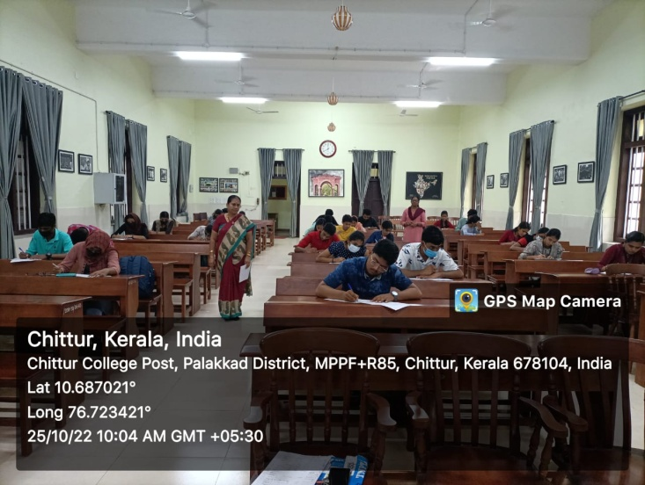

- Blood Donation Camp. (10/02/23)
A Voluntary Blood Donation Camp was organized in the college jointly by Red Ribbon Club and NSS in association with District Hospital Palakkad. During the camp 27 units of blood was collected.

