Faculty profile
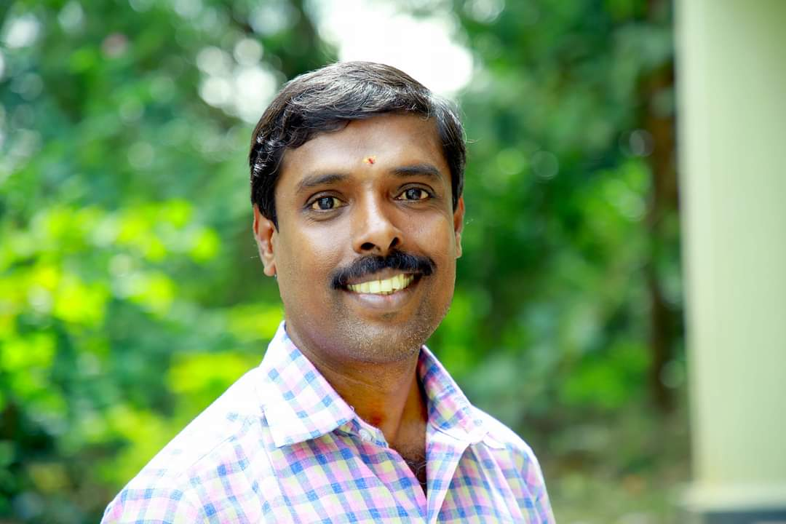
PASSPORT SIZE PHOTO

Faculty Name :Dr. K. Sivamani
Designation :Associate Professor in Tamil
PEN : 619618
Department :Dept of Tamil & Research Centre
Is HOD :No
Permanent Address :3/100, Vannamadai Post, Palakkad Dist, Kerala 678 555.
Contact Number :98427 68149
Email :sivamaniks2010@gmail.com
Experience Details :
Educational qualifications
Course | University/ Institution | Year of Pass
UG | Govt. Victoria College, Palakkad | 1995
PG | Govt. College, Chittur | 1999
M Phil | Govt. Arts College(Autonomous) Coimbatore | 2002
Ph D | N. G. M. College, Pollachi | 2009
Postdoc | No
Others (Specify) | B. Ed Govt. Teacher Education Centre, Koduvayoor Palakkad | 2000

Broad Area of Research : Modern Literature
Publications(Newest first)
1.Ilakkiya suvadugal ( Collection of Literary Essays)
2.kavignar Sirpi aayiram puu Nandhavanam
3.Arutselvar aayiram
4. Amsamum Priyamum
5. Sirpiyin kavithaikaLil manitha uravukal

Books/ Chapters Published
1.No.
2.

Paper Presentations
1. Research Papers in Peer | reviewed or UGC listed Journals | 1. Research Papers in Peer | reviewed or UGC listed Journals
Sl. No. Title of the paper and Journal details (Name, Year, Vol., Pages) Sl. No. in UGC list ISSN/ ISBN No. Whether Peer reviewed, Impact factor if any* Whether you are the Principal First/ Principal/ Corresponding author or Co-author No of Co-authors Score claimed Score approved by SC  Kerala mozhic suulazhil thmizh ilakkiyam kaRRal, kaRpiththalil IdarpaatukaL, Modern Thamizh Research, 15th May, 2021, Pages: 277- 283. ISSN 2321 – 984X UGC Care Listed (Group I) Journal Principal First Nil 15  Thirumular – Ramalingar Anbu neRic chinthanaigal, SHANLAX International Journal of Tamil Research, April 2021, Vol I, Pages: 134 – 136. P. ISSN 2321 – 788x A Peer – reviewedScholarly Indexed Quarterly Journal Principal First Nil 15  Irupathaam NuuRRaantin iNaiyaRRa sangka ilakkiya uraiyaasiriyarkaL, Modern Thamizh Research, 16.03. 2021 to 17.03.2021, Vol: IV, Pages: 838 - 840 ISSN 2321 – 984X UGC Care Listed (Group I) Journal Principal First Nil 15  Bharathi, bharathidasan, siRpi – aaththisuutikaL oppiitu, Modern Thamizh Research, 29th March, 2021, Pages: 412 - 421. ISSN 2321 – 984X UGC Care Listed (Group I) Journal Principal First Nil 15  Thirumanthirathil Valluvaththin selvaakku, SHANLAX International Journal of Tamil Research, Feb: 2020, Pages: 51 – 54. P. ISSN2454 - 3993 A Peer – reviewedScholarly Indexed Quarterly Journal Principal First Nil 15  ARaviyal nokkil sangka ilakkiyam, AYIDHA EZHUTHU, JAN 2019, VOL. IV, Pg. 36 – 38 ISSN 2278 - 7550 UGC Recognised Journal Principal First Nil 15 |  | Sl. No. Title of the paper and Journal details (Name, Year, Vol., Pages) Sl. No. in UGC list ISSN/ ISBN No. Whether Peer reviewed, Impact factor if any* Whether you are the Principal First/ Principal/ Corresponding author or Co-author No of Co-authors Score claimed Score approved by SC  Kerala mozhic suulazhil thmizh ilakkiyam kaRRal, kaRpiththalil IdarpaatukaL, Modern Thamizh Research, 15th May, 2021, Pages: 277- 283. ISSN 2321 – 984X UGC Care Listed (Group I) Journal Principal First Nil 15  Thirumular – Ramalingar Anbu neRic chinthanaigal, SHANLAX International Journal of Tamil Research, April 2021, Vol I, Pages: 134 – 136. P. ISSN 2321 – 788x A Peer – reviewedScholarly Indexed Quarterly Journal Principal First Nil 15  Irupathaam NuuRRaantin iNaiyaRRa sangka ilakkiya uraiyaasiriyarkaL, Modern Thamizh Research, 16.03. 2021 to 17.03.2021, Vol: IV, Pages: 838 - 840 ISSN 2321 – 984X UGC Care Listed (Group I) Journal Principal First Nil 15  Bharathi, bharathidasan, siRpi – aaththisuutikaL oppiitu, Modern Thamizh Research, 29th March, 2021, Pages: 412 - 421. ISSN 2321 – 984X UGC Care Listed (Group I) Journal Principal First Nil 15  Thirumanthirathil Valluvaththin selvaakku, SHANLAX International Journal of Tamil Research, Feb: 2020, Pages: 51 – 54. P. ISSN2454 - 3993 A Peer – reviewedScholarly Indexed Quarterly Journal Principal First Nil 15  ARaviyal nokkil sangka ilakkiyam, AYIDHA EZHUTHU, JAN 2019, VOL. IV, Pg. 36 – 38 ISSN 2278 - 7550 UGC Recognised Journal Principal First Nil 15
 |  | 1. Research Papers in Peer | reviewed or UGC listed Journals

Areas Of Interest :
- Modern Literature Kavithai
- Bhakthi Literature

Field of Research :
- Modern Literature Kavithai

Research Projects and Grants
Sl No | Title | Funding Agency | Amount Sanctioned | Year
1 | No
2

Research Guideship Details
Number of students registered for Ph D : Five
Number of students awarded :Two
Seminars / Workshops Organized
6. Invited lectures / Resource Person/ Paper presentation in Seminars/ Conferences/Full paper in Conference Proceedings*# | Sl. No. Title of Lecture/ Paper/ Academic Session Name of Conference/ Seminar and by whom Organized Nature of Participation (IL/RP/ Paper Presentation/ Full Paper) Whether International/ National/ State/ University level Score claimed Score approved by SC  Sirpi kavithaigalil manitha UrvugaL, National Seminar on Panpaatu nookkil thamizh ilakkiyam, Dept. Of Tamil, Govt. Arts and science college, Valparai From 02.06. 2020 to 05.06.2020. Resource Person National (Through On line) 3  Ilakkanam kaRRal, kaRpiththalil itarpaatukaL, Ilakkanam kaRRal, karpiththalil itarpaatukaL, Dept. Of Tamil, Kamadenu college of arts and science, sathiyamangalam. Erode Dt, on 20th Feb 2020. Resource Person National Level workshop 3  Thirumuular thirumanthiram kaattum vaazkkai weRigaL, Dept. Of Tamil, Erode Arts and science college, Erode, 04.01.2020, Paper Presentation National Seminar 3  IlakkaNam kaRpiththal : sikkal maRRum thiirvu, Dept. Of Tamil, N.G.M. College, Pollachi, 2,3rd February, 2021. Resource Person National Seminar 3  ThaRkaalath thamiz ilakkiya aayvup pookkugaL, SFR College for Women ( Autonomous), Sivakasi on 29,30th August 2019 Resource Person National Level Workshop 3  Teaching Tamil Literature in Kerala Environment, Dept. Of. Tamil, Dravidian University, Kuppam, Andra Pradesh on 6, 7th March 2019 Resource Person National Seminar 3
6. Invited lectures / Resource Person/ Paper presentation in Seminars/ Conferences/Full paper in Conference Proceedings*# | Sl. No. Title of Lecture/ Paper/ Academic Session Name of Conference/ Seminar and by whom Organized Nature of Participation (IL/RP/ Paper Presentation/ Full Paper) Whether International/ National/ State/ University level Score claimed Score approved by SC  Sirpi kavithaigalil manitha UrvugaL, National Seminar on Panpaatu nookkil thamizh ilakkiyam, Dept. Of Tamil, Govt. Arts and science college, Valparai From 02.06. 2020 to 05.06.2020. Resource Person National (Through On line) 3  Ilakkanam kaRRal, kaRpiththalil itarpaatukaL, Ilakkanam kaRRal, karpiththalil itarpaatukaL, Dept. Of Tamil, Kamadenu college of arts and science, sathiyamangalam. Erode Dt, on 20th Feb 2020. Resource Person National Level workshop 3  Thirumuular thirumanthiram kaattum vaazkkai weRigaL, Dept. Of Tamil, Erode Arts and science college, Erode, 04.01.2020, Paper Presentation National Seminar 3  IlakkaNam kaRpiththal : sikkal maRRum thiirvu, Dept. Of Tamil, N.G.M. College, Pollachi, 2,3rd February, 2021. Resource Person National Seminar 3  ThaRkaalath thamiz ilakkiya aayvup pookkugaL, SFR College for Women ( Autonomous), Sivakasi on 29,30th August 2019 Resource Person National Level Workshop 3  Teaching Tamil Literature in Kerala Environment, Dept. Of. Tamil, Dravidian University, Kuppam, Andra Pradesh on 6, 7th March 2019 Resource Person National Seminar 3
2

Professional Appointments(Such as Chairman, Director etc)
Sl No | Position | Name of Institution/Body | Date/Year
1 | No
2

Recognition and Awards
Sl No | Name of Award | Agency | Year
1 | No
2

Academic &Administrative Responsibilities
- Convenior, NET Coaching

Any Other Details to Specify:

