Faculty profile
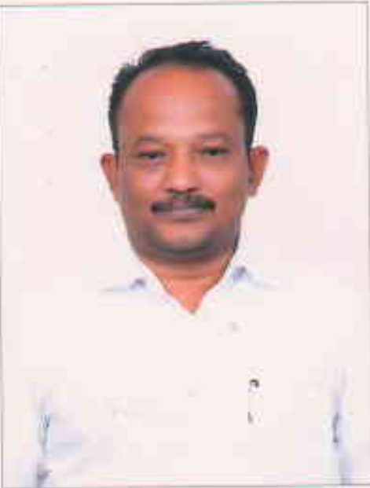
PASSPORT SIZE PHOTO

Faculty Name : Dr. N. MANOHARAN
Designation : Assistant Professor
PEN : 619619
Department : Tamil
Is HOD : No
Permanent Address : Sashvatham H , Nombikode, Elappully Po Palakkad 6786222
Contact Number : 9495838234
Email : manotamil2011@gmail.com
Experience Details : 14 years in collegiate education
Educational qualifications
Course | University/ Institution | Year of Pass
UG | University of Calicut | 1991
PG | University of Calicut | 1993
M Phil | Bharathiar University , Coimbatore | 1998
Ph D | University of Calicut | 2016
Postdoc | Nil
Others (Specify) | B.Ed Kerala University | 1995

Broad Area of Research : Tamil Language and Literature
Publications (Newest first)
1.Sanga Ilakakkiyam Malayala Mozhipeyarppukal in Aayvuchudar Internation Multy Disciplinary Journal January 2020 ISSN 2581-5938
2. Velliveethiyar IJLCA Vol 3 Issue 1 January March 2017 ISSN 2394-6385 (print) 2394-6393 (online0
3.

Books/ Chapters Published
1. Translation works
Malayalam to Tamil
- ഈന്ത്യന്‍ സാഹിത്യ സിദ്ധാന്തം പ്രസക്തിയും സാദ്ധ്യതയും
കെ. അയ്യപ്പപണിക്കര്‍ - இந்திய இலக்கியக் கோட்பாடுகள் - சூழல் பொருத்தம்.

- The book awarded as best translation work of 2013 by Nalli Thisai Ettum Translation Award with an entitle of BHASHA BHOOSHAN
English to Tamil
- Educational Thought in Ancient Tamil Literature – Rev. Xavier Thaninayakam -
பழந்தமிழ் இலக்கியங்களில் கல்விக் சிந்தனைகள் – Published by IITS, Chennai.

Paper Presentations
Sl No | Title of paper | Name of Conference | Date
1
2

Areas Of Interest :
- Translation

Field of Research :
- Tamil Language and literature
- Translation Studies
Research Projects and Grants
Sl No | Title | Funding Agency | Amount Sanctioned | Year
1 | Studies on Manimekalai and An Annotated Bibliography | UGC | 1,50,000 | 2015
2 | Malayalam Translations of Tamil Classical Literature : History and Method of Translation | CICT , Chennai | 2,00,000 | 2018

Research Guideship Details
Number of students registered for Ph D : Four – On going : Co Guiding 3
Number of students awarded : Nil
Seminars / Workshops Organized Nil
Sl No | Name of the Programme | Venue | Date
1
2

Professional Appointments (Such as Chairman, Director etc)
Sl No | Position | Name of Institution/Body | Date/Year
1 | Chair person PGBS Tamil Univers | University of Calicut | 2020
2 | Member PGBS Tamil | Mahathma Gandhi University, Kottayam | 2021
3 | Member in BOS Tamil - UG | Ramakrishna Mission Arts & Science College, Coimbatore | 2022

Recognition and Awards
Sl No | Name of Award | Agency | Year
1 | Bhashabhooshan – Best Translation 2013 | Nalli – Thisai Ettum | 2013
2

Academic & Administrative Responsibilities
- Member in Examination Committee
- Member in Library Committee

Any Other Details to Specify: Nil
Dr. N. Manoharan

